**Report about conducted scalability test**

**Date:** 20-27 July 2022

**Author:** Oleksandr Maksymenko

**Application:** BlogEngine.NET version 3.2

**Environment:** Host machine where script was run + Virtual Machine where blog is deployed

**Load Model:**

|  |  |
| --- | --- |
|  | **Load Model** |
| **Anonymous** Users | 60 |
| **Anonymous** Rump up time (s) | 120 |
| **Admin** Users | 2 |
| **Admin** Rump up time (s) | 120 |
| **Editor** Users | 8 |
| **Editor** Rump up time (s) | 120 |
| **Duration (s)** | 600 |

**Comparison of Anonymous script step probabilities:**

|  |  |
| --- | --- |
| **Action** | **Probability** |
| Open Home Page | 15% |
| Open Random Date | 10% |
| Open Predefined Date | 30% |
| Search by Name | 30% |
| Open Large Calendar | 10% |
| Open Contacts | 5% |

|  |  |
| --- | --- |
| **Action:** Open Random Page | **Probability** |
| Yes | 50% |
| No | 50% |

|  |  |
| --- | --- |
| **Action:** Open Post | **Probability** |
| Yes | 80% |
| No | 20% |

|  |  |
| --- | --- |
| **Action:** Open First or Random Post | **Probability** |
| First | 35% |
| Random | 65% |

|  |  |
| --- | --- |
| **Action:** Send Comment | **Probability** |
| Yes | 20% |
| No | 80% |

1. **Why such testing was conducted:** To find optimal system configuration for Blog Engine app.
2. **Test script description:** Current script is combined script of 3 different role user scenarios: Anonymous, Admin and Editor.
   1. **Anonymous Script:** contains different user scenarios which are chosen with different probabilities (Open Home Page, Open Random Date, Open Predefined Date, Search Post by Name, Open large calendar, Open contacts). First three scenarios are opening random page with posts (in 50% cases). All scenarios (except Open Contacts) have Open Page script, which is used randomly in ~80% cases. Detailed description can be found on screenshots and in tables below.
   2. **Admin Script:** contains actions for Admin flow. Firstly “user” opens Home page, Logs In, after that starts loop which executes 10 times: Open Admin Page -> Open Users Page -> depending on current number of users -> Create User OR Delete User. After loop ends “user” will be logged off.
   3. **Editor Script:** contains actions for Editor flow. Firstly “user” opens Home page, Logs In, after that starts loop which executes 50 times: Open Predefined Date -> Open Random Page (in case editable post was not found on first page) -> Open Random Post -> Edit Post. After loop ends “user” will be logged off.

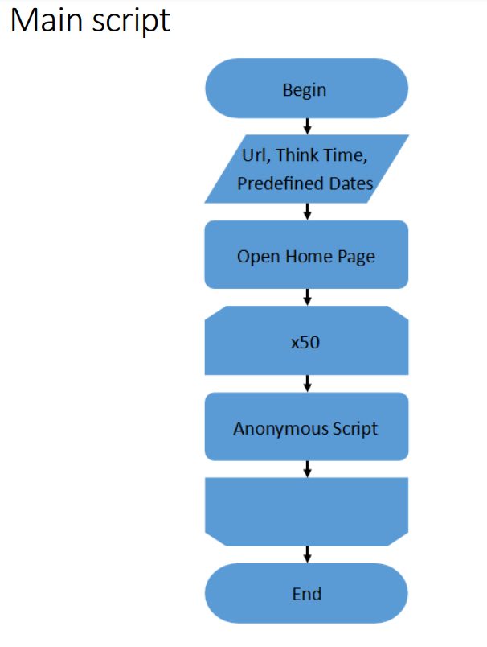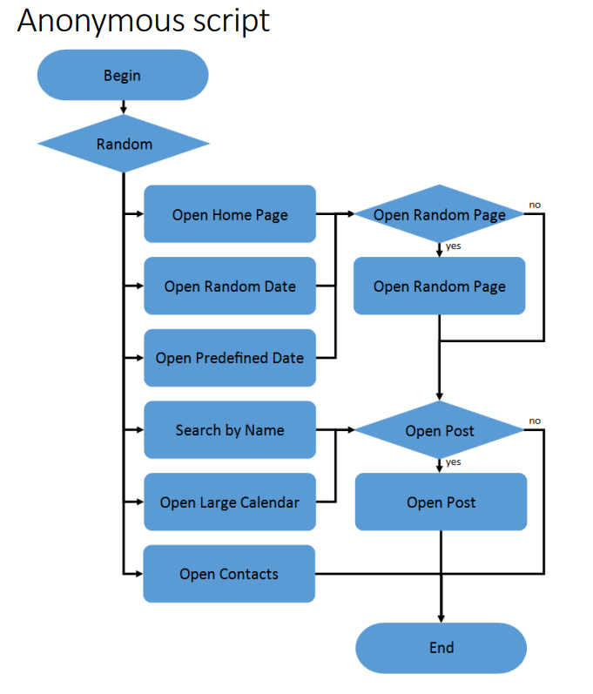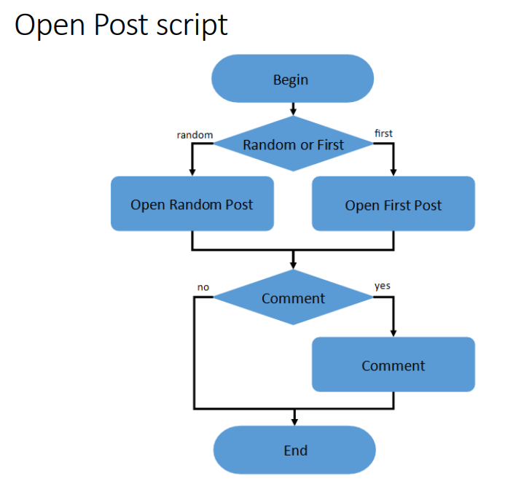

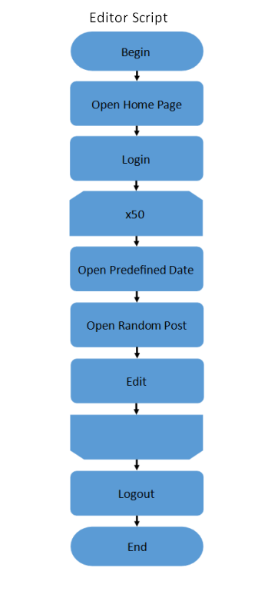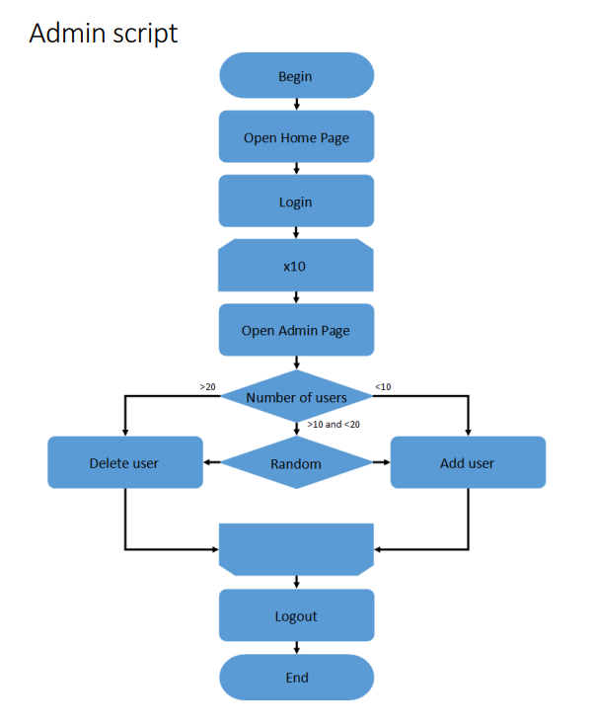

# Tests preconditions and configurations

**Test run preconditions:**

* 1000 pregenerated posts on predefined dates
* CSV file with 10 predefined dates
* CSV file with Admin credentials
* CSV file with Editor credentials

**Why that Load Model was chosen:** task 7 test execution showed saturation point on ~90 users, so number of anonymous users was set to 60 users, editor users to 8, and admin users remained the same at 2. Rampup period was set to 2 minutes, and other 8 minutes we had stable load.

**Initial Environment configuration (RAM, CPU etc.):**

|  |  |
| --- | --- |
| **RAM** | 4096 MB |
| **CPU** | 1 Core CPU (Intel(R) Core(TM) i7-8665U CPU @ 1.90GHz 2.11 GHz) |
| **System Type** | Windows 10 64-bit |

**Test Environment configuration (scalable CPU, fixed RAM):**

|  |  |  |  |  |
| --- | --- | --- | --- | --- |
| **CPU** | 1 Core | 2 Core | 3 Core | 4 Core |
| **RAM** | 8 GB | | | |

**Test Environment configuration (scalable RAM, fixed CPU):**

|  |  |  |  |  |
| --- | --- | --- | --- | --- |
| **CPU** | 2 Core | | | |
| **RAM** | 2048 MB | 4096 MB | 6144 MB | 8192 MB |

# Short summary on conducted tests:

**Default system configuration:**

|  |  |
| --- | --- |
| **CPU** | 1 Core |
| **RAM** | 4 GB |
| **Throughput (transactions per sec)** | 21.44 |
| **Error rate, %** | 0.03 |
| **Average response time, ms** | 255.62 |
| **Median response time, ms** | 205.5 |
| **90%, ms** | 1191.2 |
| **95%, ms** | 2235.8 |

**Scalable CPU:**

|  |  |  |  |  |
| --- | --- | --- | --- | --- |
| **CPU** | 1 Core | **2 Core** | 3 Core | 4 Core |
| **RAM** | 8 GB | | | |
| **Throughput (transactions per sec)** | 20.9 | **22.68** | 22.59 | 21.42 |
| **Error rate, %** | 0.79 | **0.12** | 0.19 | 0.97 |
| **Average response time, ms** | 372.66 | **103.81** | 108.61 | 280.43 |
| **Median response time, ms** | 554.5 | **76.5** | 83.5 | 361.5 |
| **90%, ms** | 2130.5 | **176.3** | 327.4 | 901.1 |
| **95%, ms** | 4671.9 | **841.8** | 861.95 | 1523.5 |

In that table we can compare test results between default configuration (1 Core CPU and 4 GB RAM) and different amounts of CPU (from 1 to 4 Cores) with fixed RAM (8 GB). Error rate increased for all CPU cases comparing to default config, but highest value was for 1 and 4 Cores CPU, nearly 1%, for 2 and 3 Cores that value was lower than 0.2%, with lowest point at 0.12% for 2 Core CPU case. Also, 2 Core CPU configuration had highest throughput rate and lowest response time metrics. While all Key Performance Indicators were close to each other for 2 Core and 3 Core CPU cases – it was chosen to keep 2 Core CPU as fixed value for test cases with scalable RAM, since it has lower cost to buy and maintain. Further in Detailed Test Results we can see application and system behavior for all test cases with scalable CPU and fixed RAM and ensure that response time graph was most stable in case of 2 Core CPU.

**Scalable RAM:**

|  |  |  |  |  |
| --- | --- | --- | --- | --- |
| **CPU** | 2 Core | | | |
| **RAM** | 2 GB | **4 GB** | 6 GB | 8 GB |
| **Throughput (transactions per sec)** | **22.77** | 22.54 | 22.24 | 22.68 |
| **Error rate, %** | 0.97 | **0.11** | 0.28 | 0.12 |
| **Average response time, ms** | **87.37** | 98.65 | 127.33 | 103.81 |
| **Median response time, ms** | **68** | 72 | 78.5 | 76.5 |
| **90%, ms** | 179.3 | 175.8 | **138** | 176.3 |
| **95%, ms** | 652.65 | 578.1 | **360.8** | 841.8 |

Tests with fixed CPU (2 Cores) and scalable RAM showed next results: error rate is still higher than in case of Default configuration (1 Core CPU + 4 GB RAM), lowest rate was for 4 GB (0.11%) and 8 GB (0.12%), highest for 2 GB (0.97%). Median response time was similar in all cases, lowest time was in case of 2 GB (68 ms), highest in case of 6 GB (78.5 ms). For 90% and 95% percentiles we have opposite picture, where 6 GB RAM case has the lowest response time (138 ms and 360.8 ms respectively) and similar higher values (from 175 to 180 ms) for 90%, and much higher values for 95% percentile (the highest in case of 8 GB – 841.8 ms). Also, important to say that 2 GB and 6 GB cases were unstable comparing to 4 GB and 8 GB cases. Their results were different in 2-3 test executions, and it required to launch tests more to find some stability in test behavior and metrics results, while 4 GB and 8 GB cases showed closely the same numbers for their 2-3 runs. Looking at all that data we can conclude that 4 GB RAM and 2 Core CPU is most optimal configuration for Blog application. Detailed results with screenshots can be found in “Scalable RAM (fixed CPU: 2 Cores)” section.

# Detailed test results:

## Default **system** configuration

**Composite Graph (Active Threads, Throughput, Average Response Time, Errors per sec)**

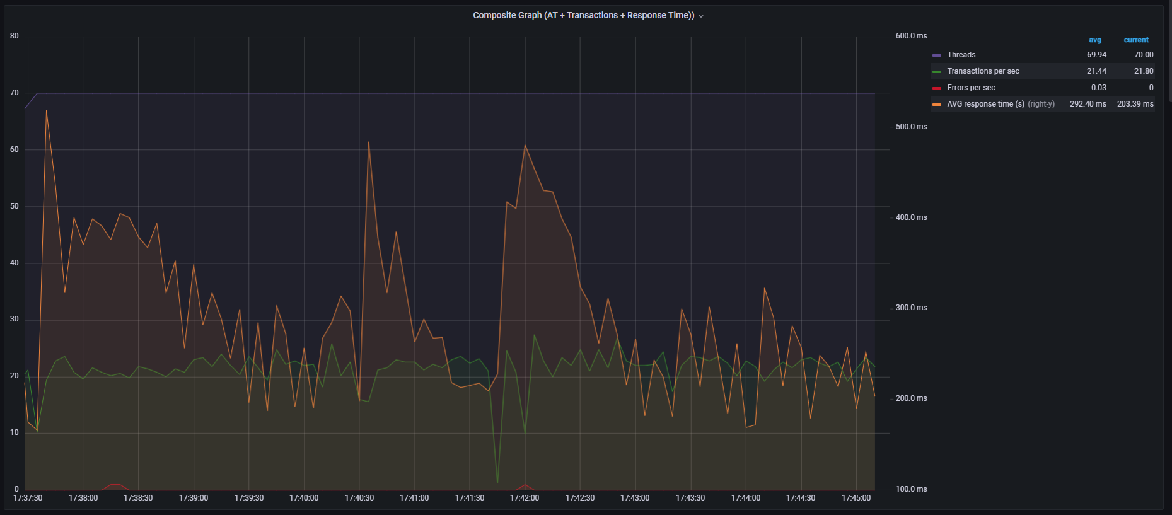

**Aggregate Report**

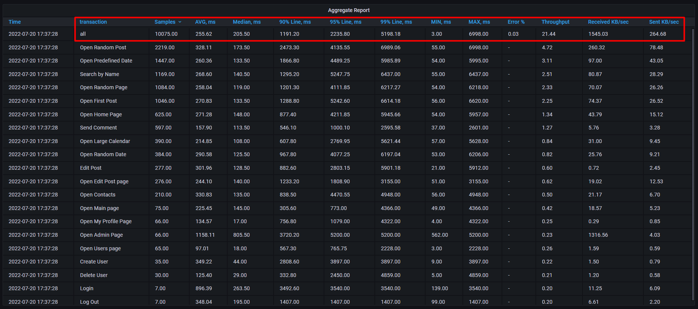

**All transaction response times**

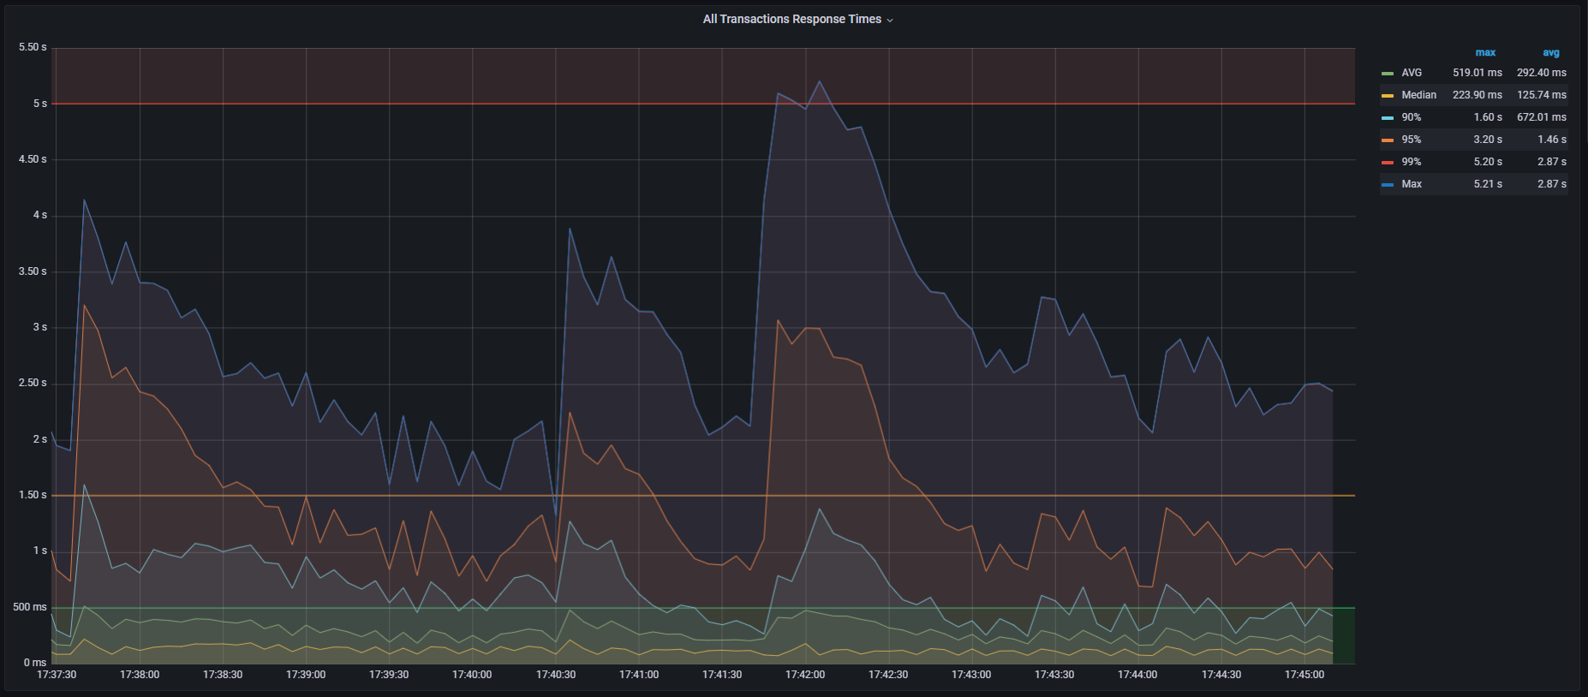

**CPU load**

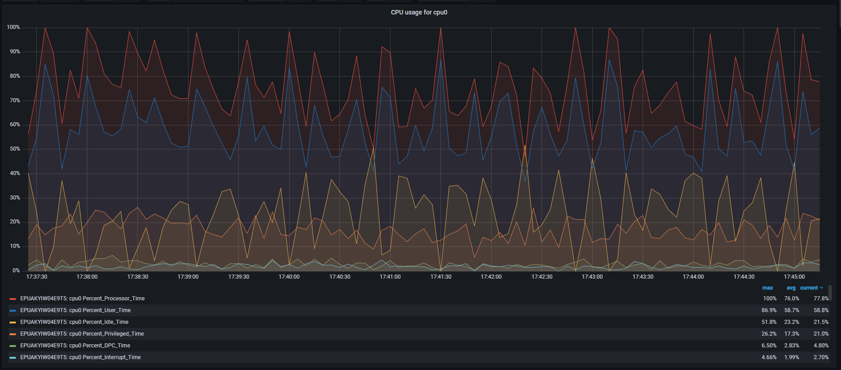

**Memory usage**

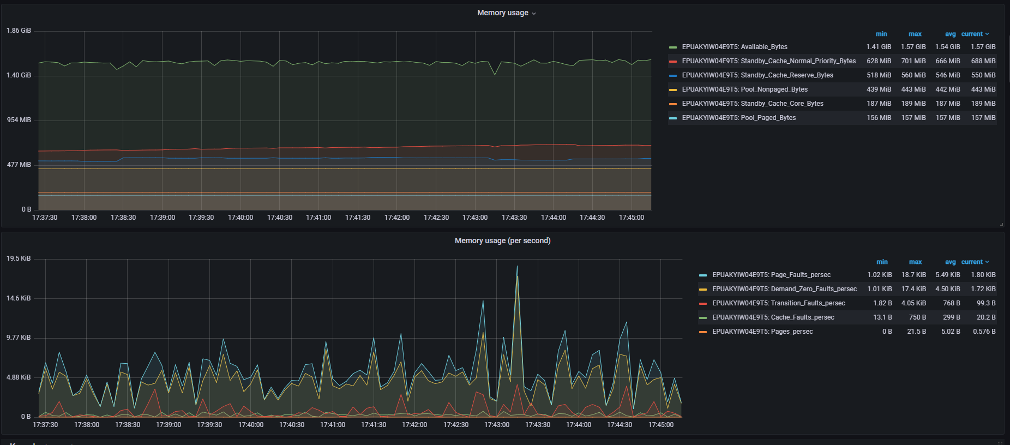

**Garbage Collector**

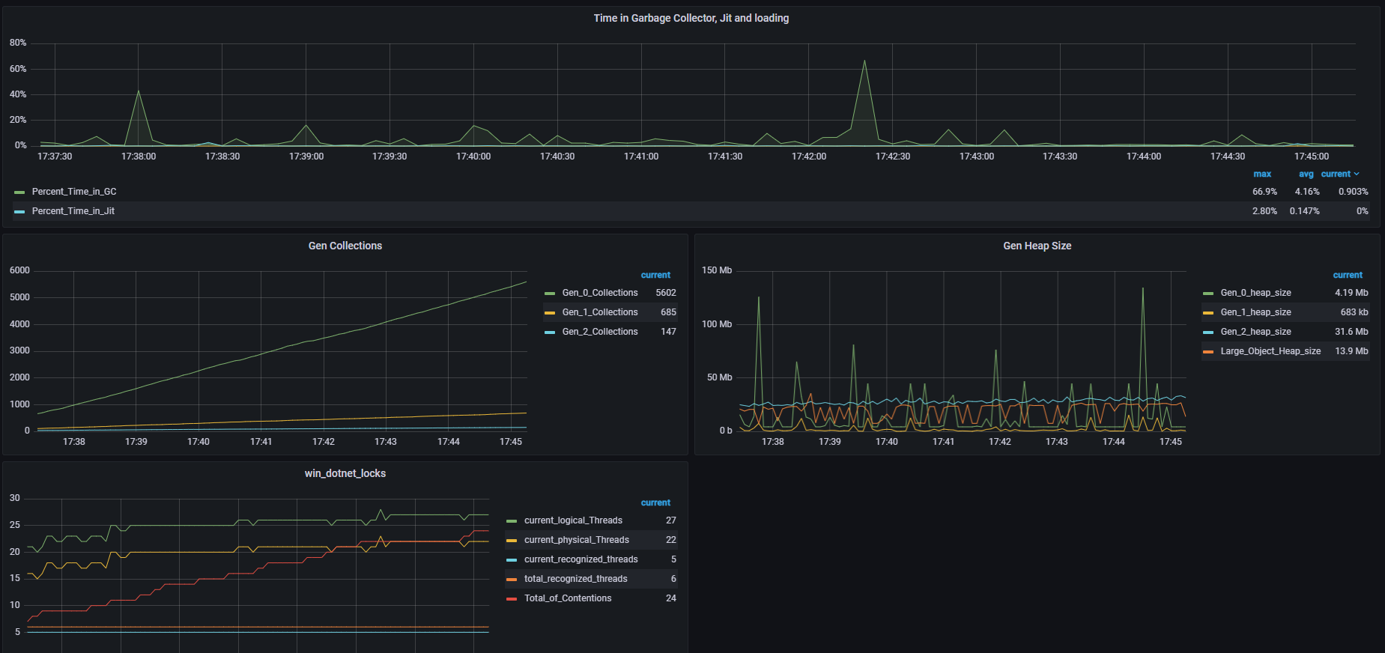

**Cache**

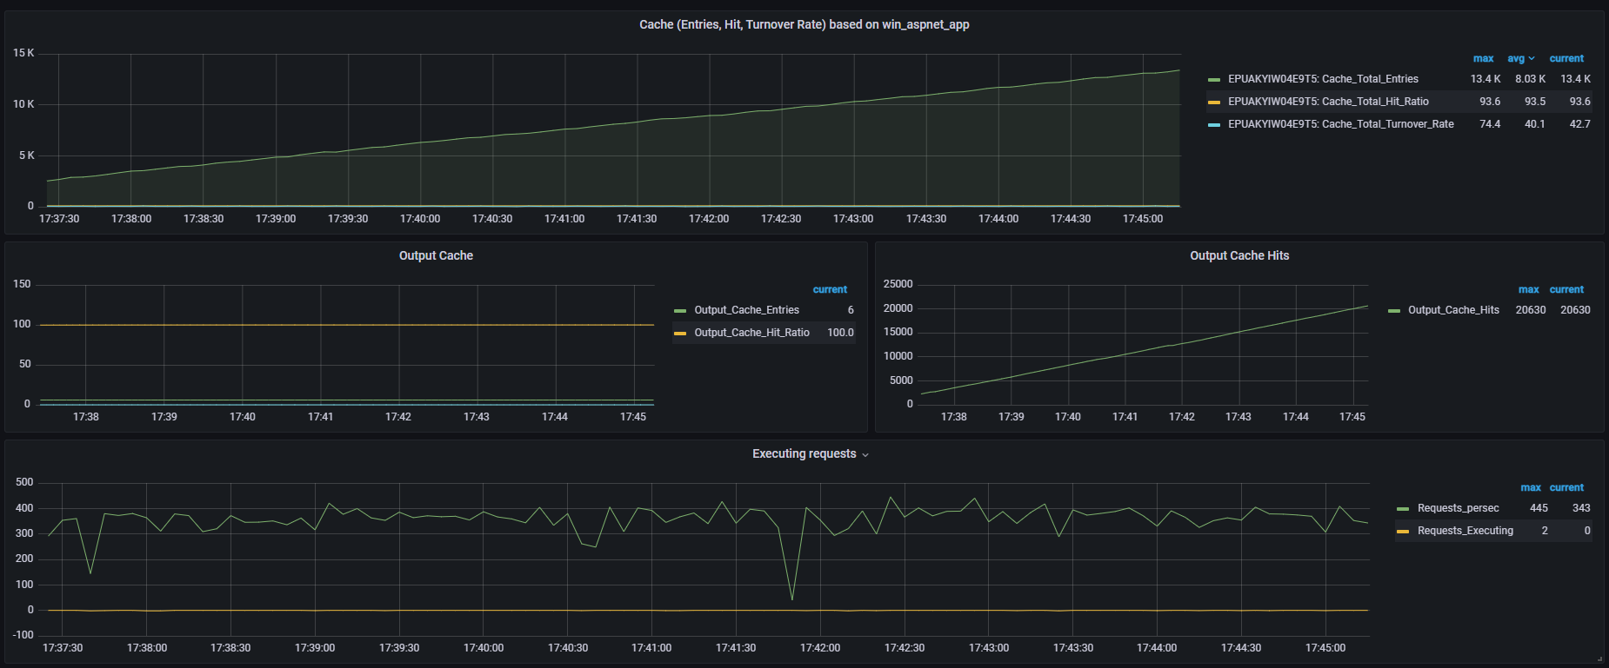

## Scalable CPU (fixed RAM: 8192 MB)

### 1 Core CPU

**Composite Graph (Active Threads, Throughput, Average Response Time, Errors per sec)**

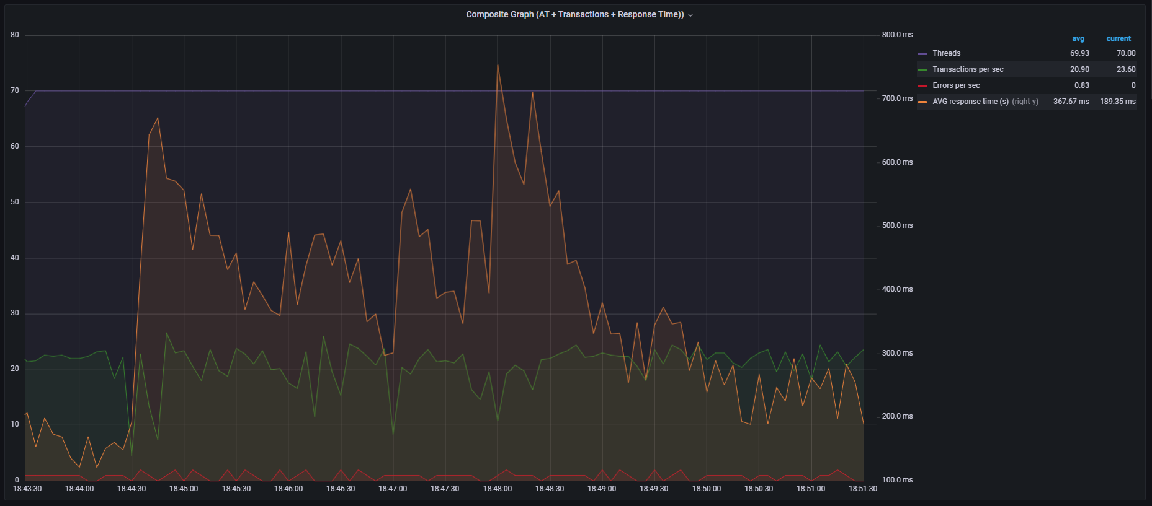

**Aggregate Report**

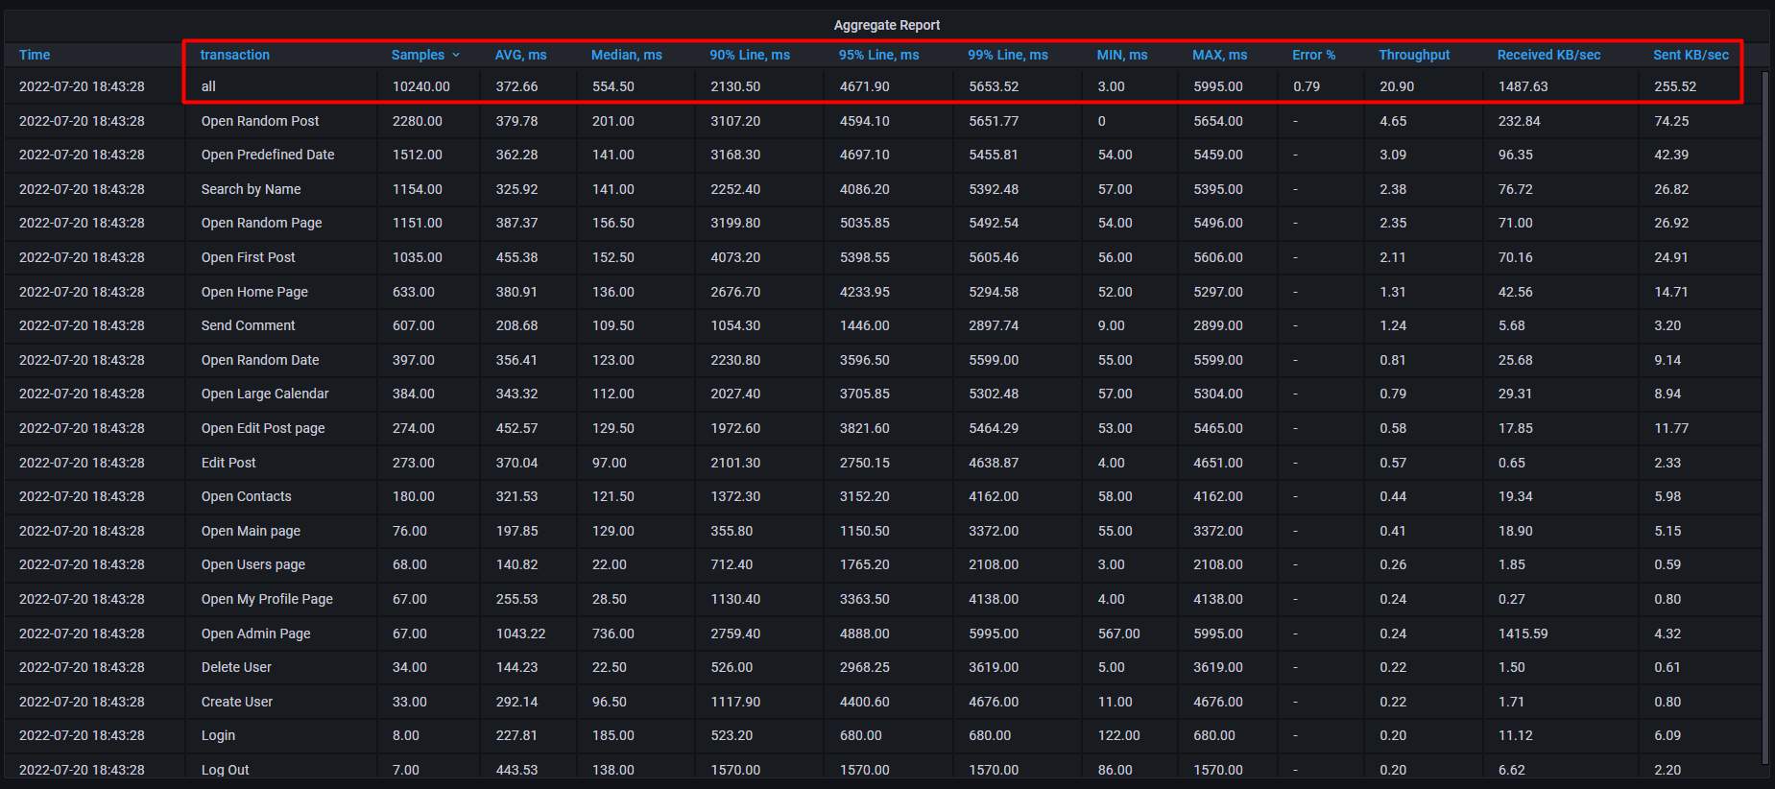

**All transaction response times**

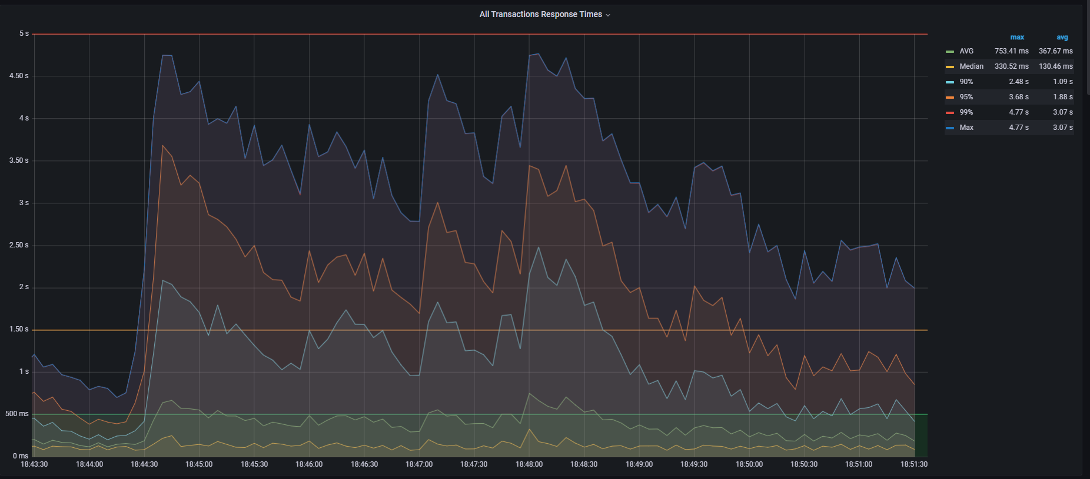

**CPU load**

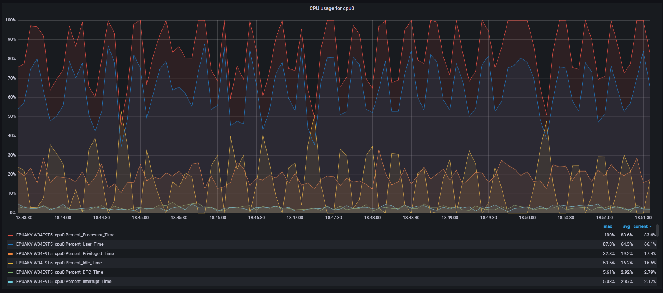

**Memory usage**

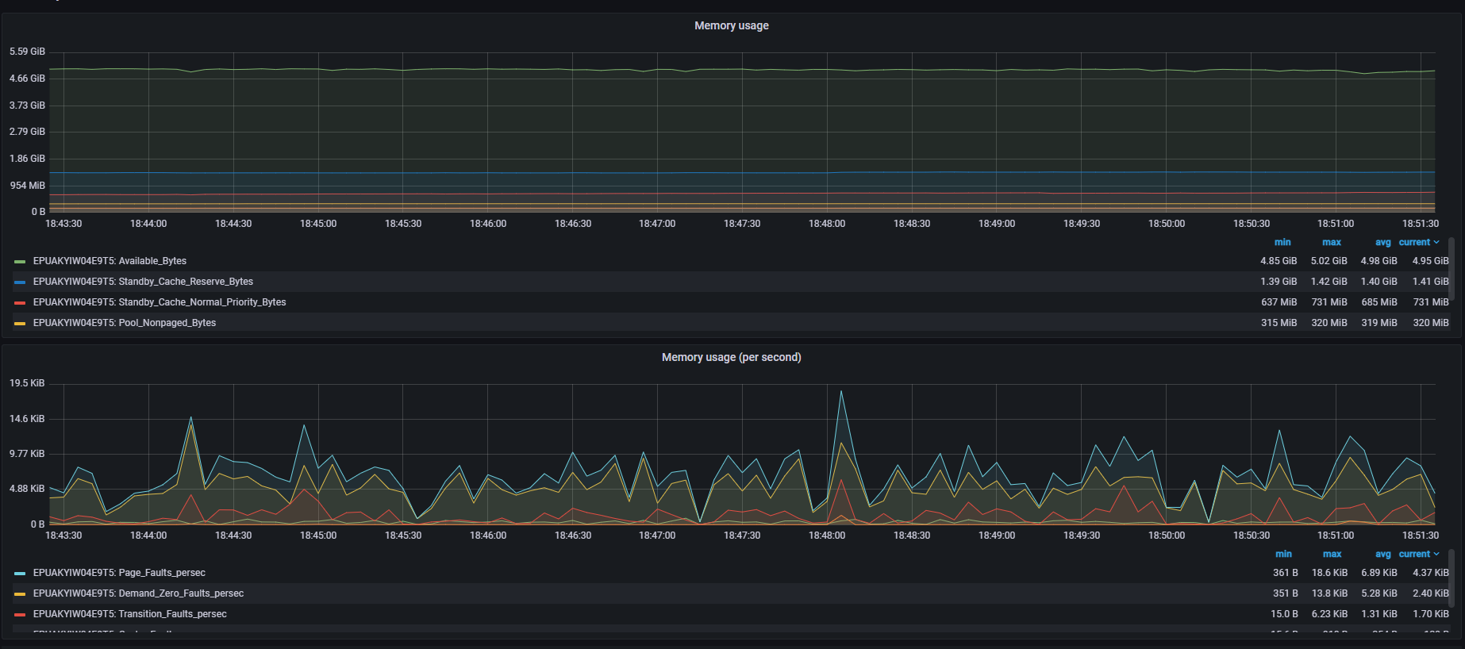

**Garbage Collector**

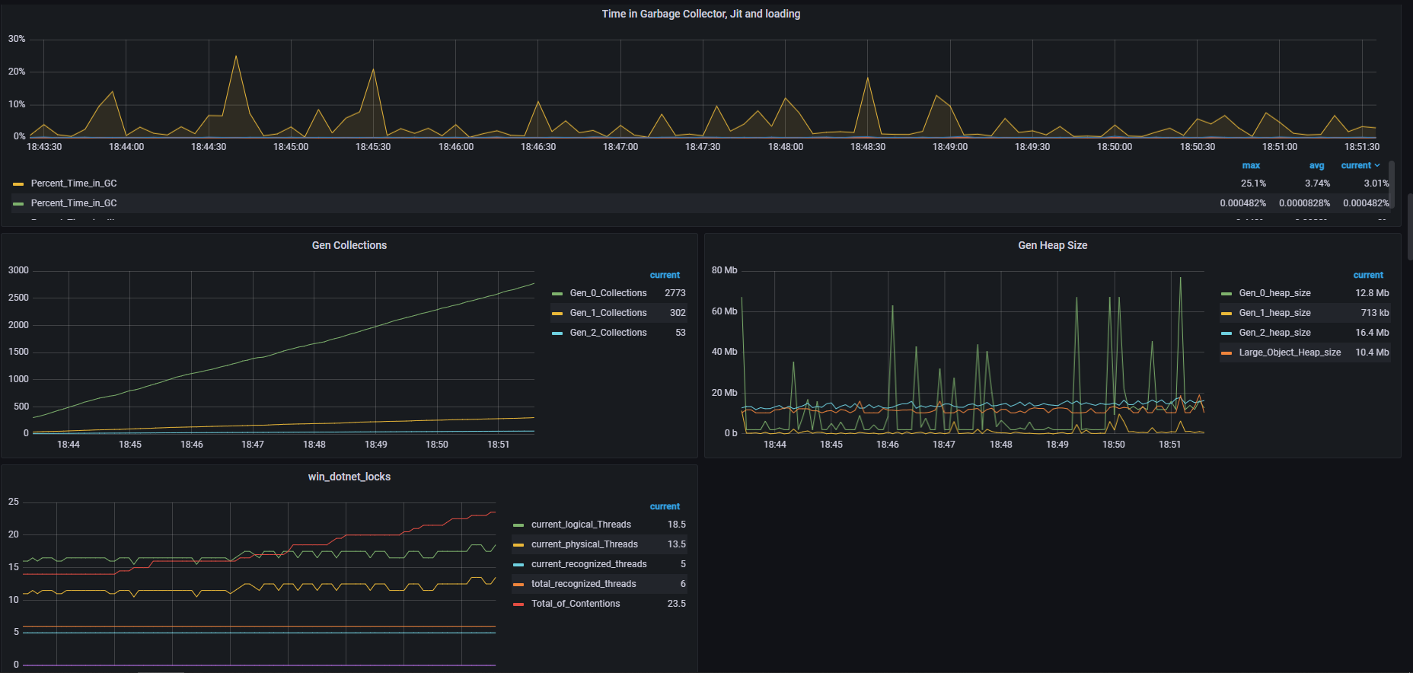

**Cache**

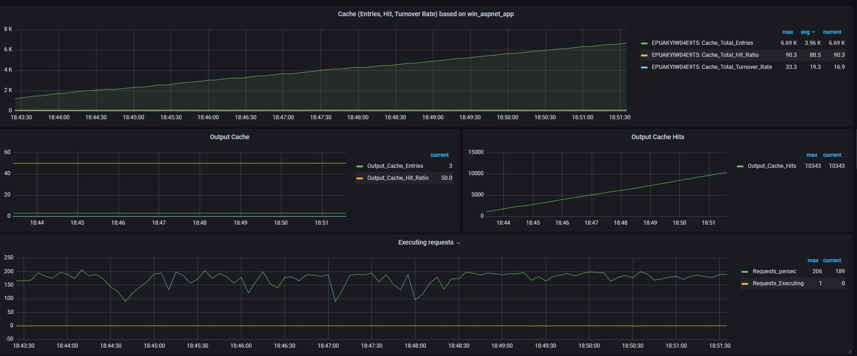

### 2 Cores CPU

**Composite Graph (Active Threads, Throughput, Average Response Time, Errors per sec)**

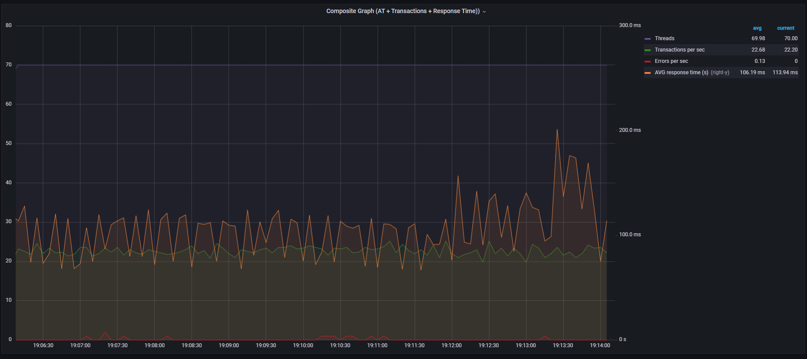

**Aggregate Report**

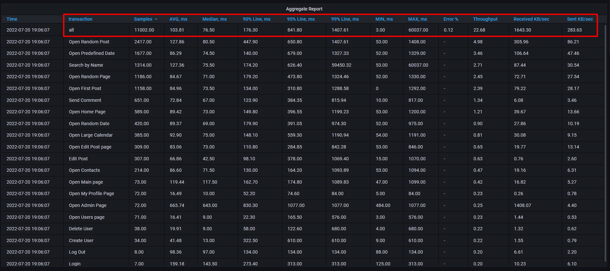

**All transaction response times**

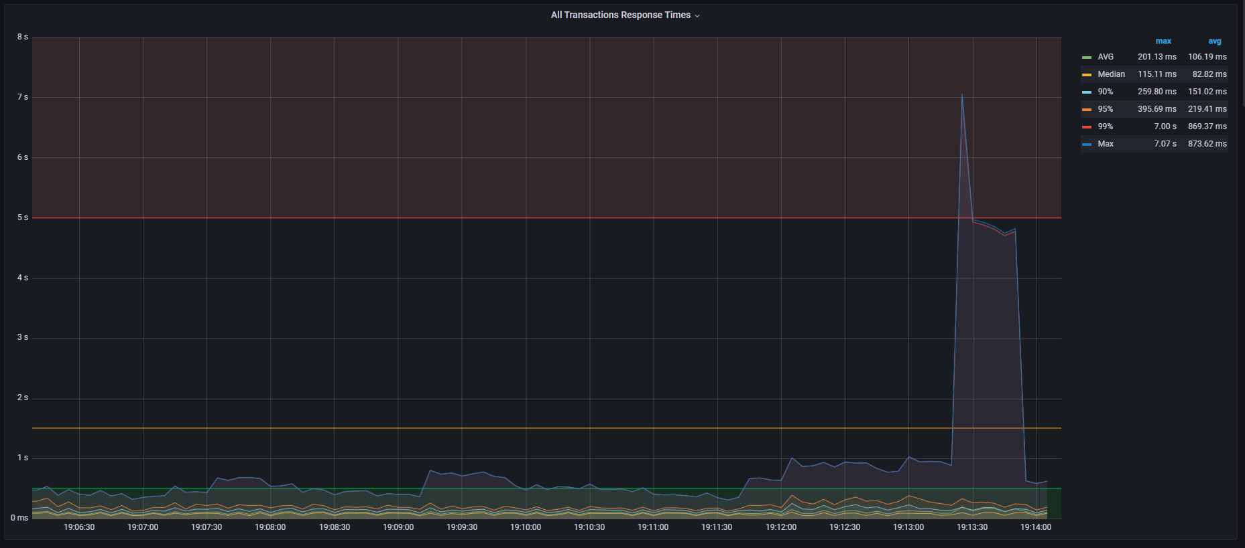

**CPU load**

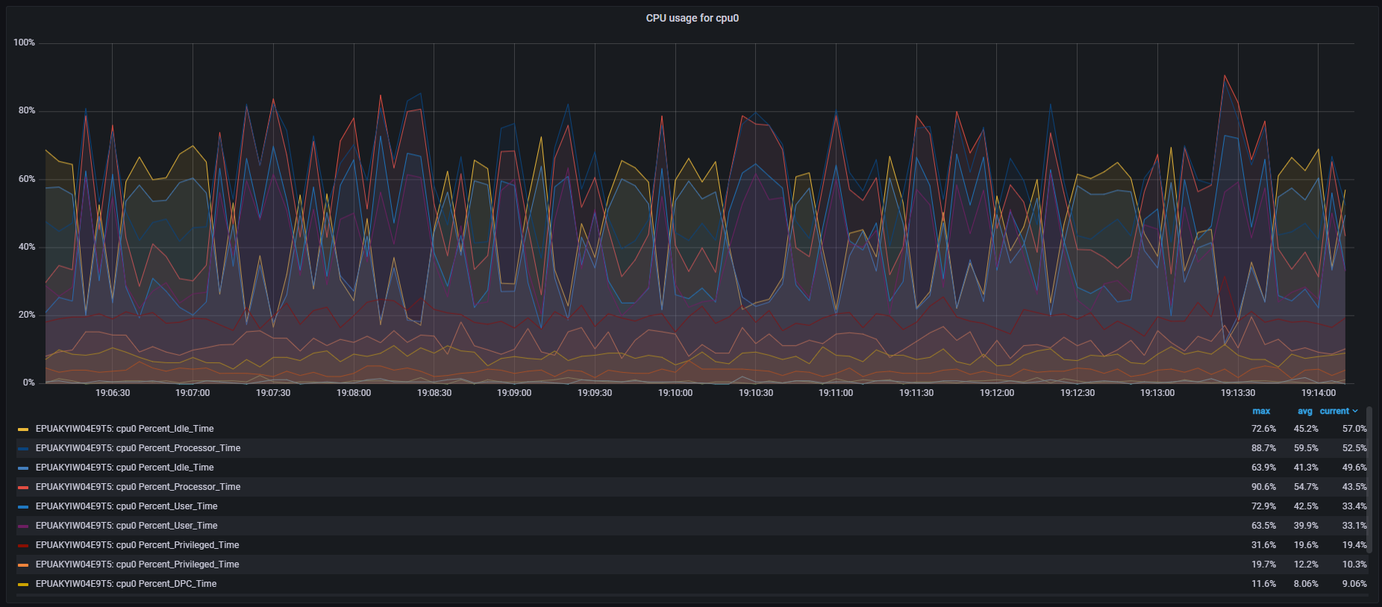

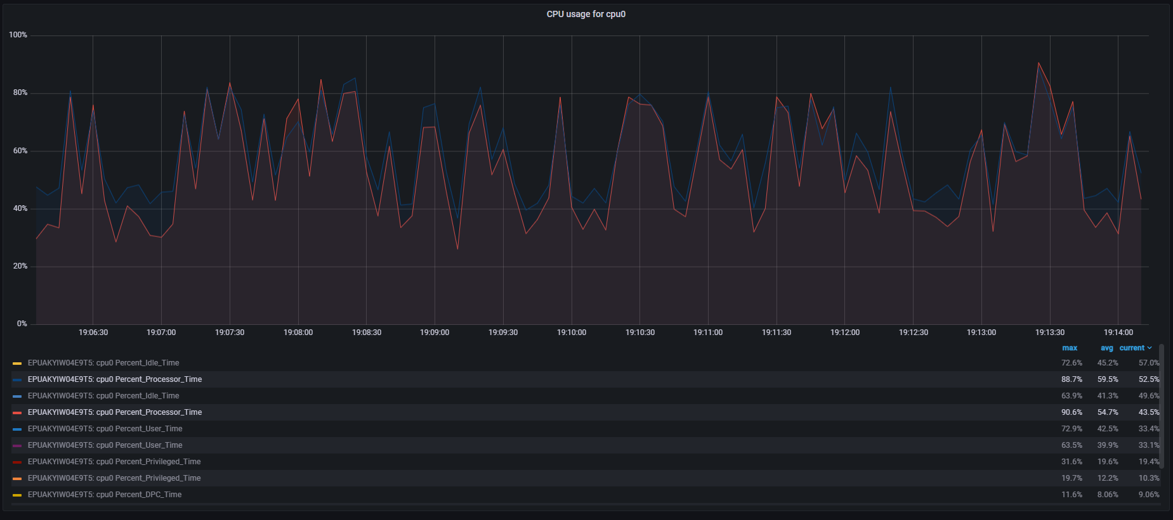

**Memory usage**

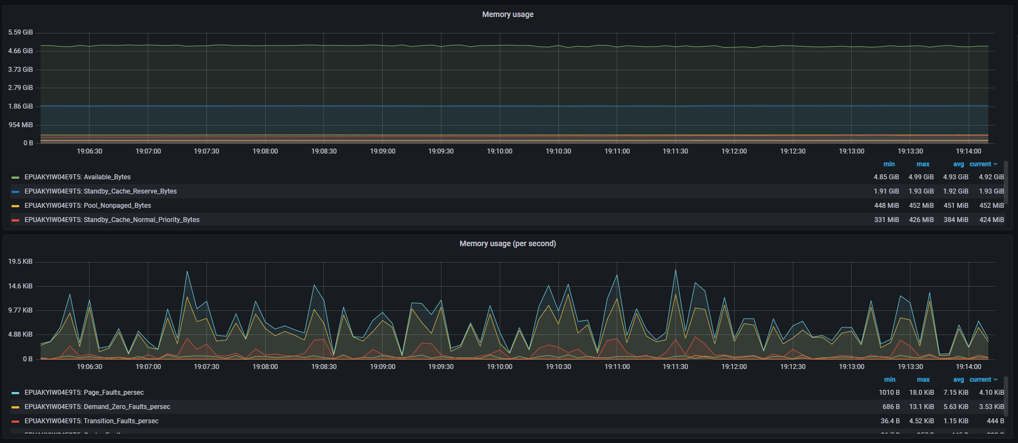

**Garbage Collector**

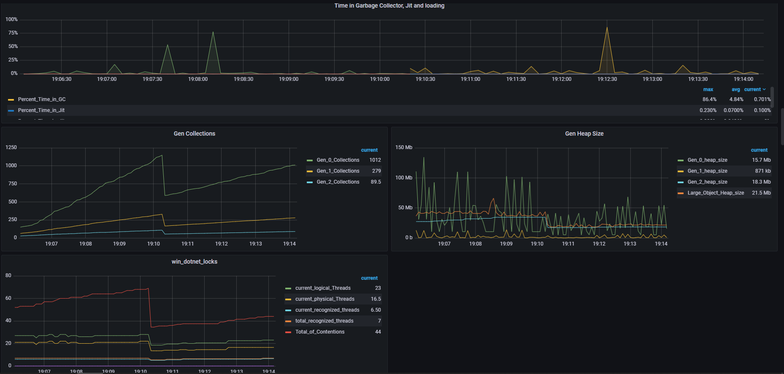

**Cache**

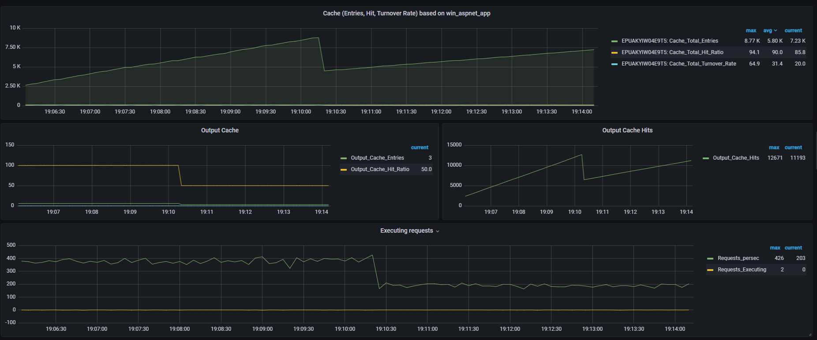

No application restarts, only w3wp and w3wp#1 switch

### 3 Cores CPU

**Composite Graph (Active Threads, Throughput, Average Response Time, Errors per sec)**

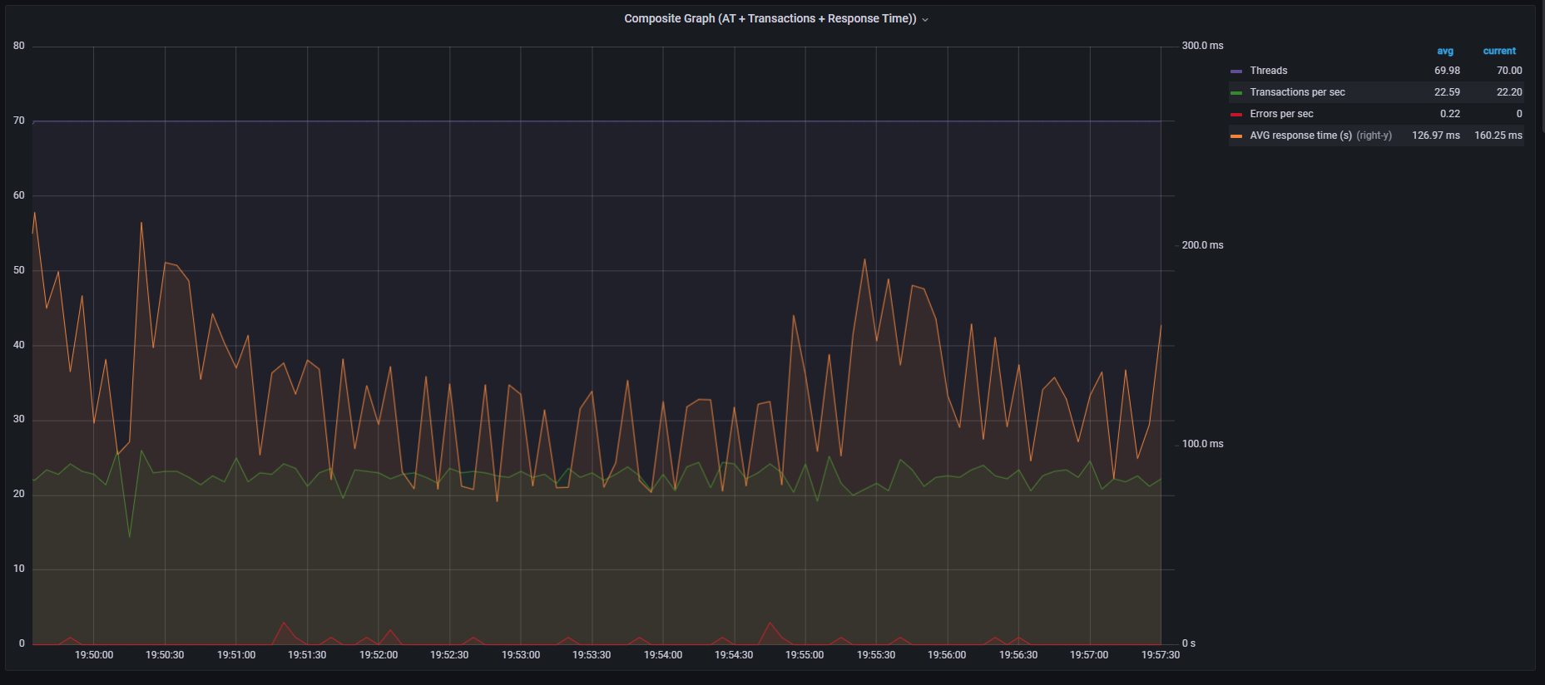

**Aggregate Report**

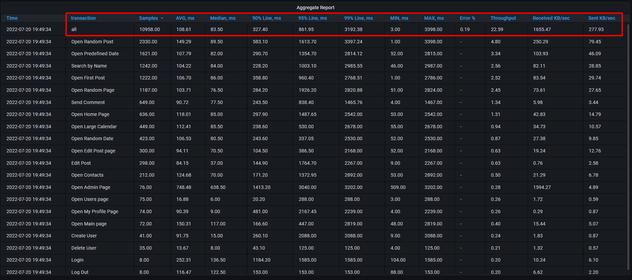

**All transaction response times**

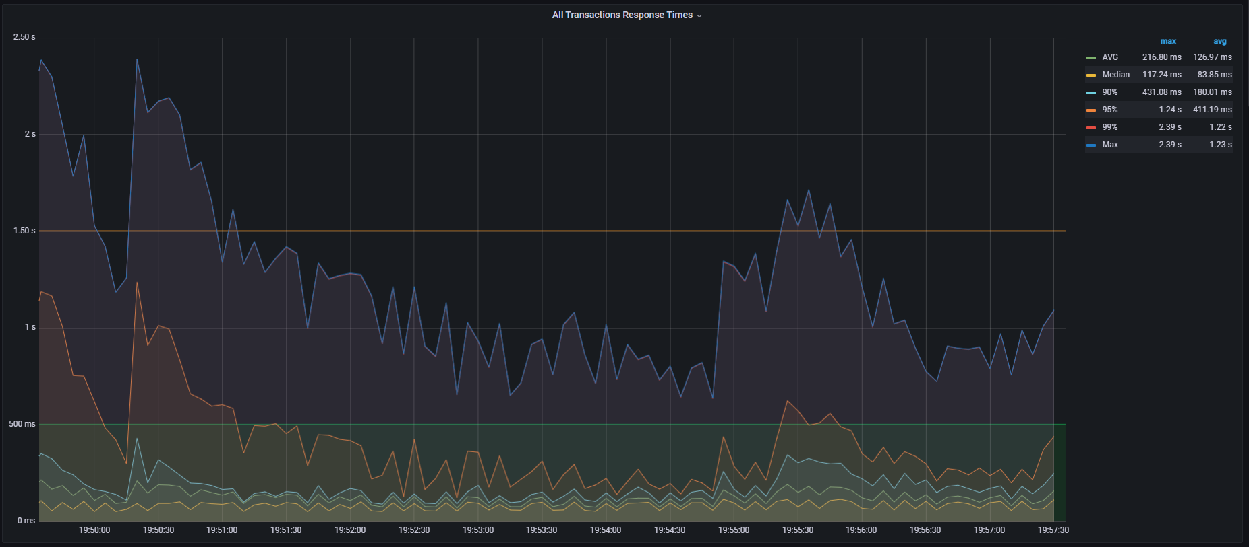

**CPU load**

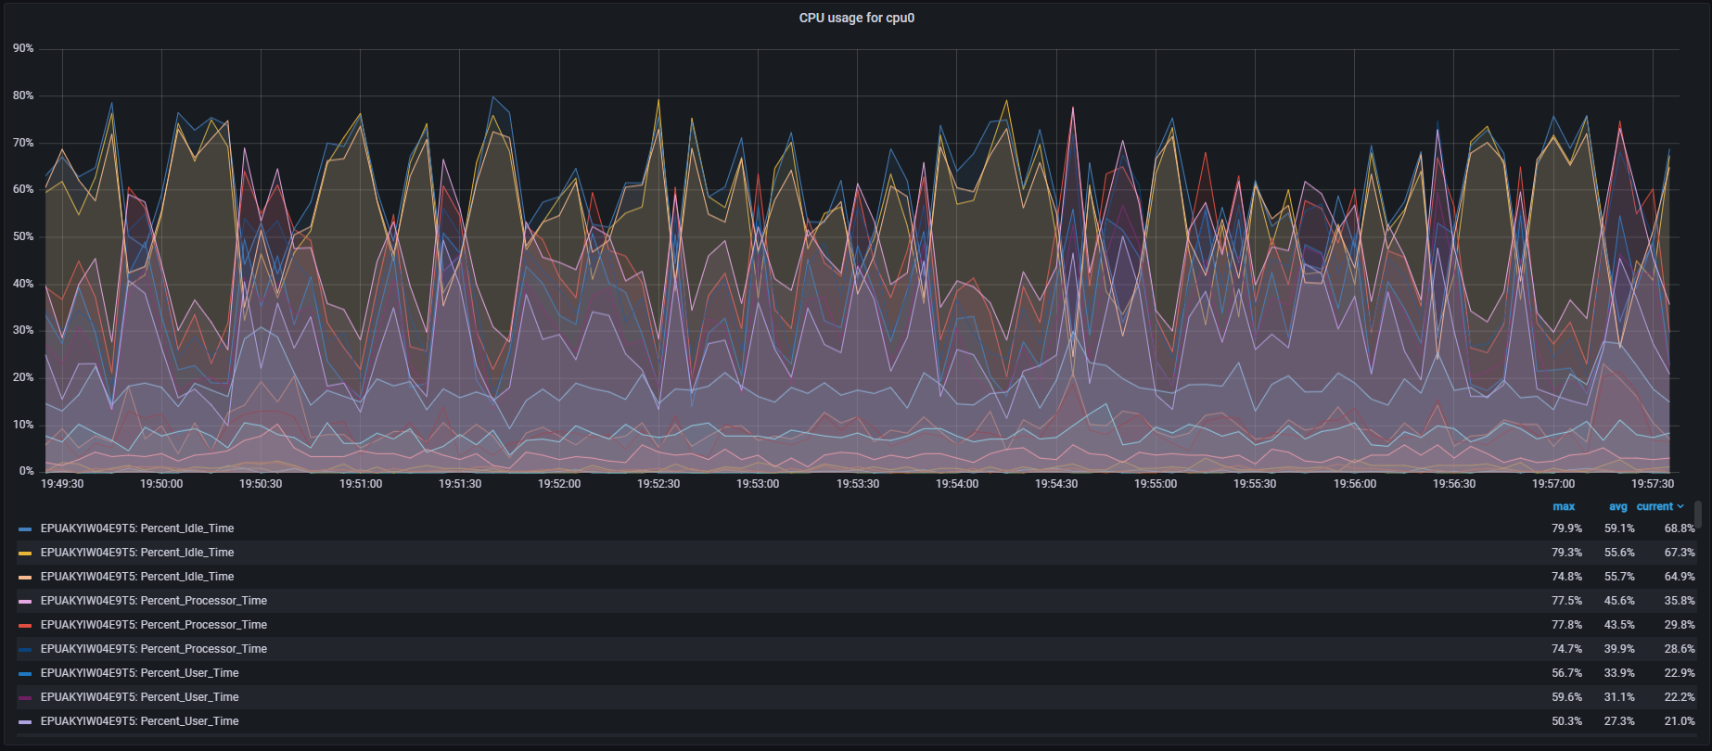

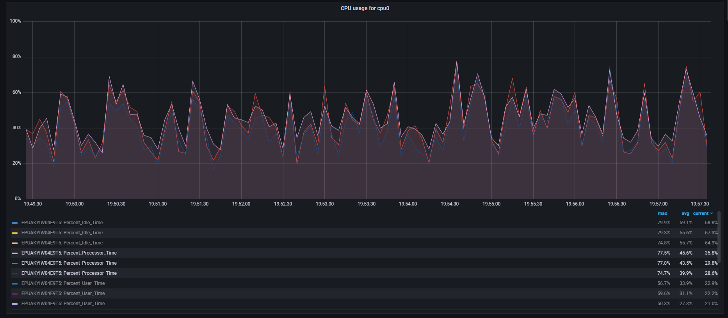

**Memory usage**

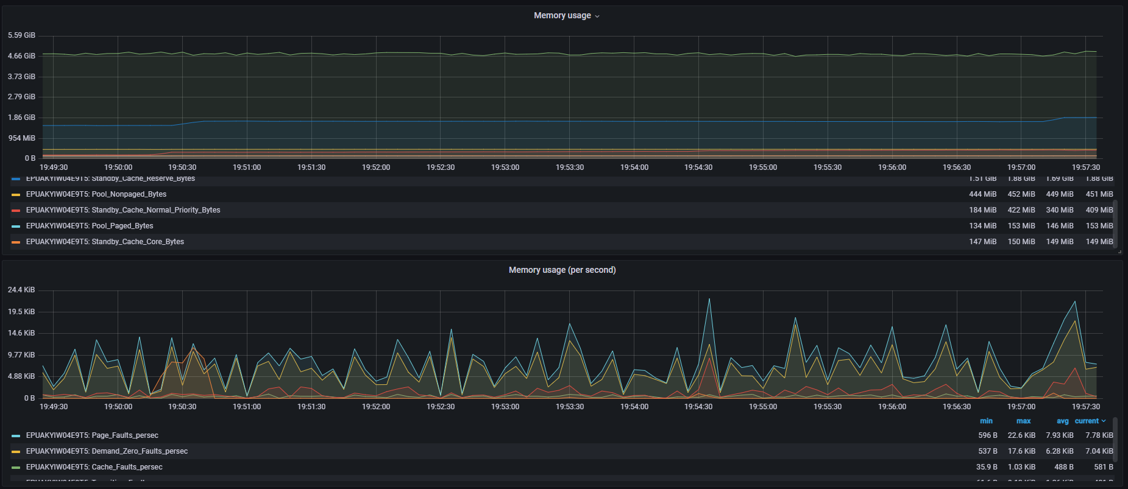

**Garbage Collector**

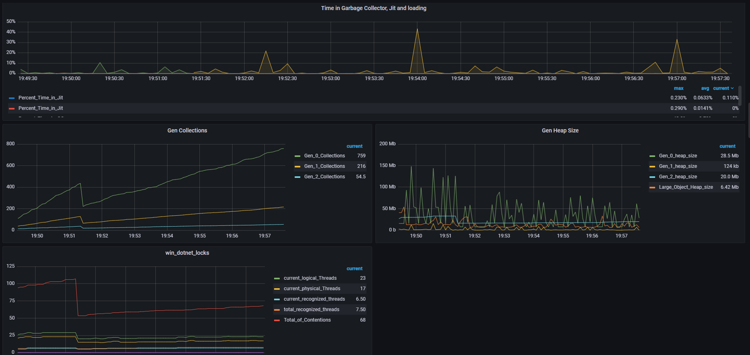

**Cache**

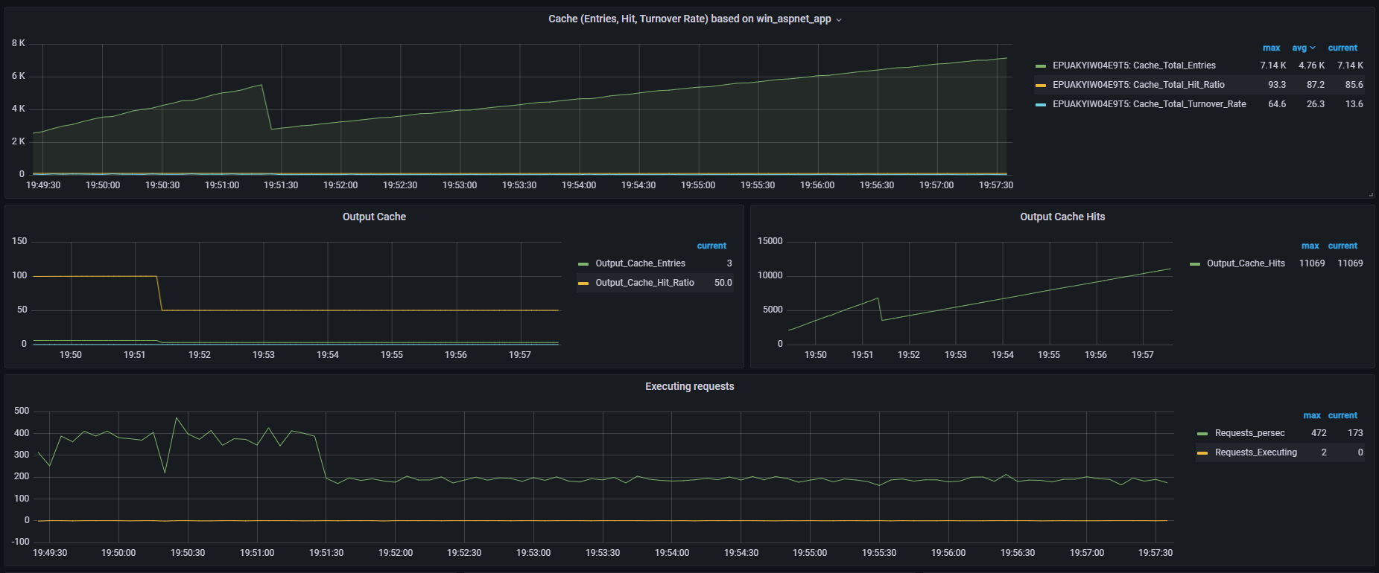

No application restarts, only w3wp and w3wp#1 switch

### 4 Cores CPU

**Composite Graph (Active Threads, Throughput, Average Response Time, Errors per sec)**

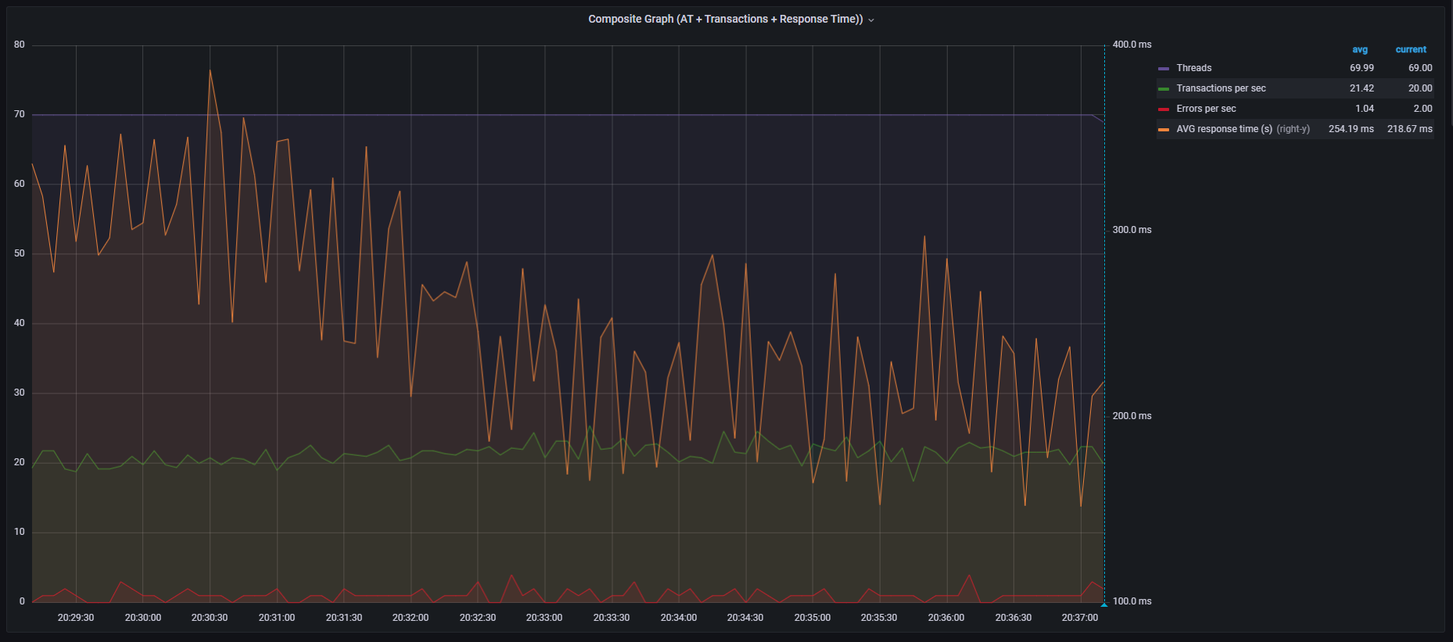

**Aggregate Report**

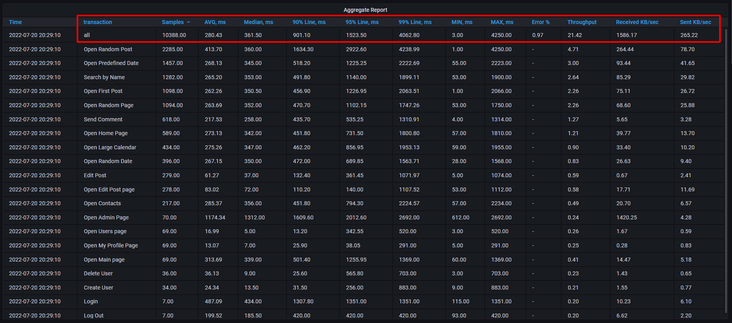

**All transaction response times**

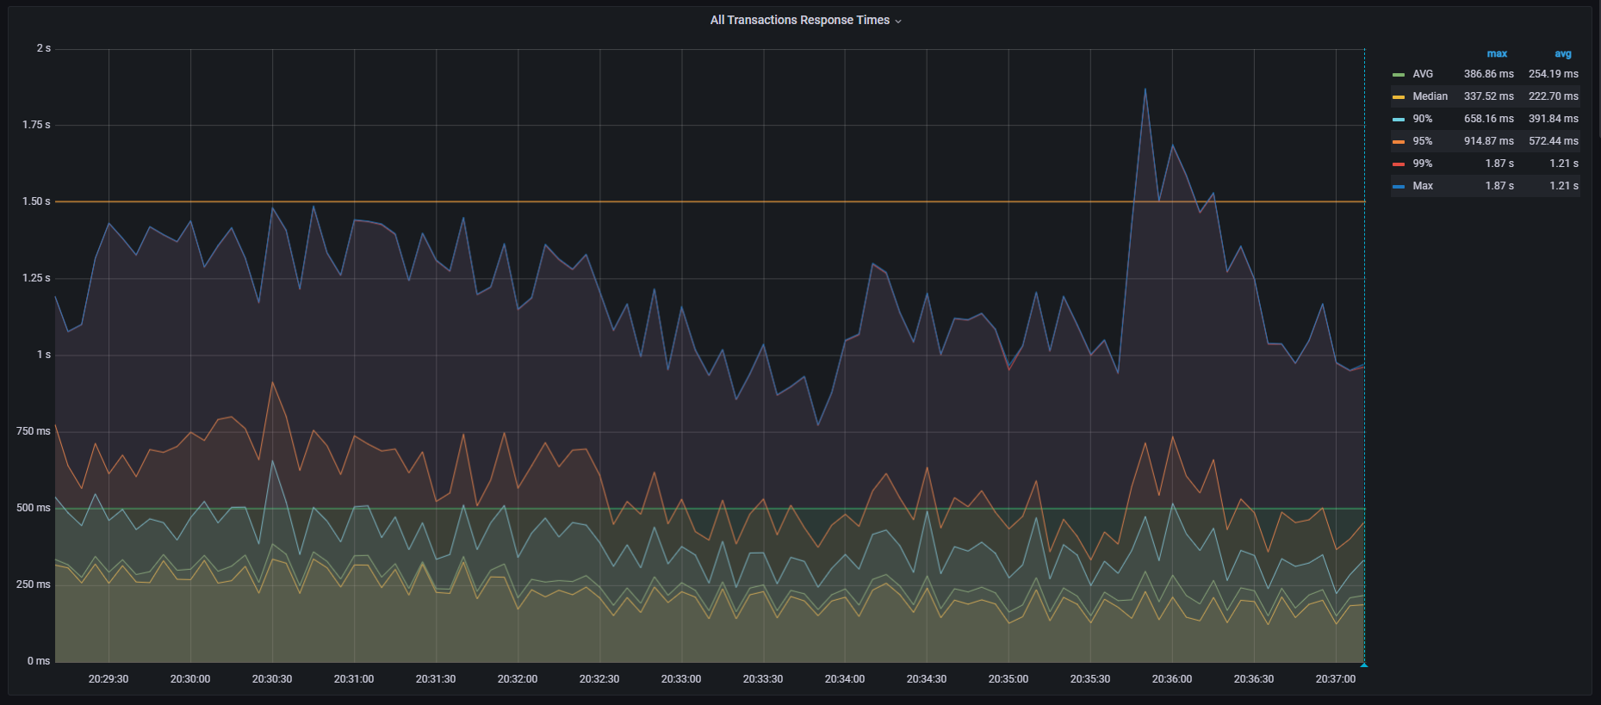

**CPU load**

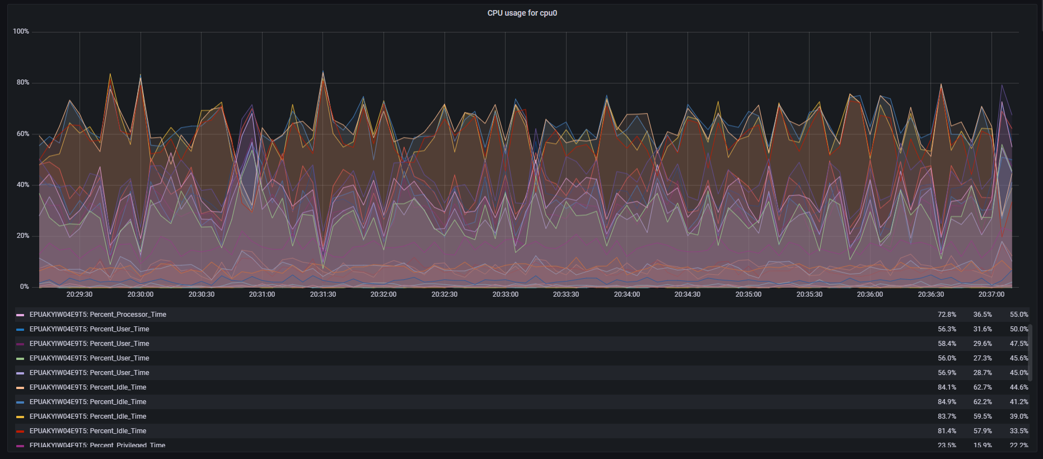

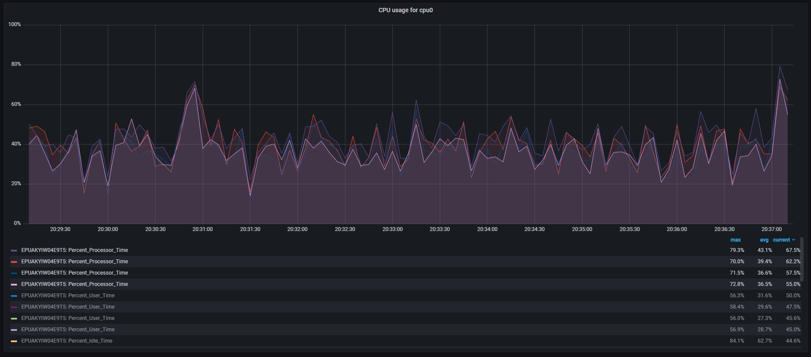

**Memory usage**

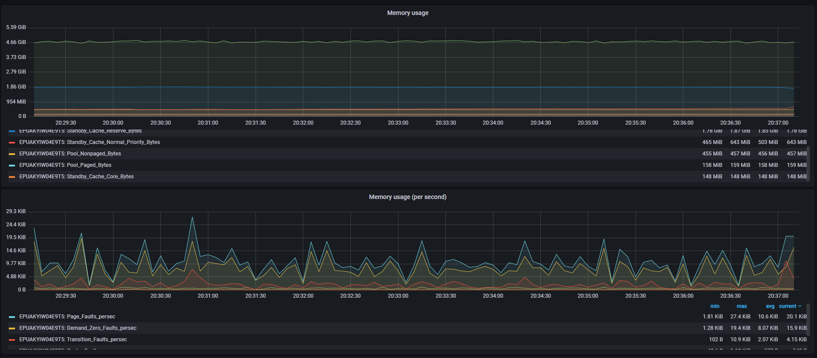

**Garbage Collector**

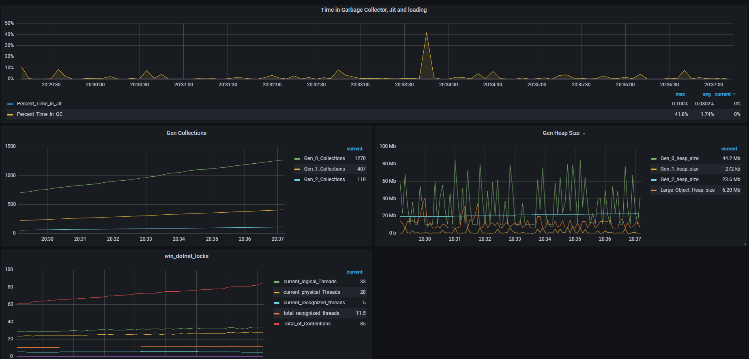

**Cache**

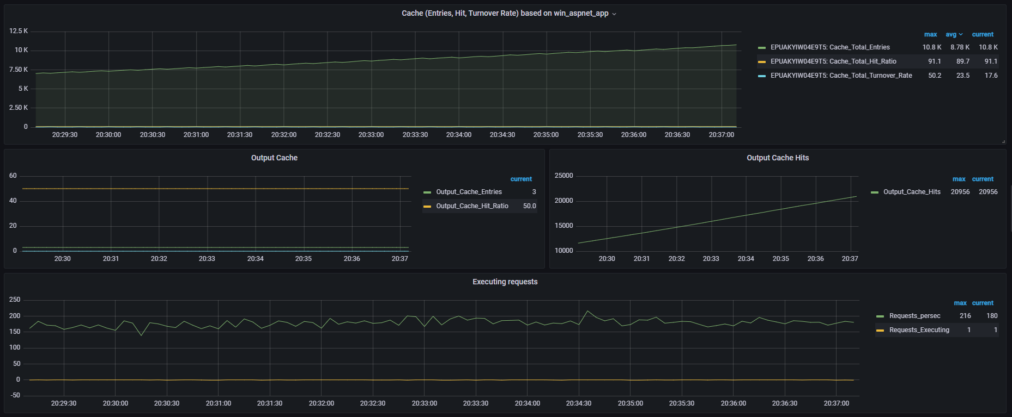

## Scalable RAM (fixed CPU: 2 Cores)

### 2048 MB RAM

**Composite Graph (Active Threads, Throughput, Average Response Time, Errors per sec)**

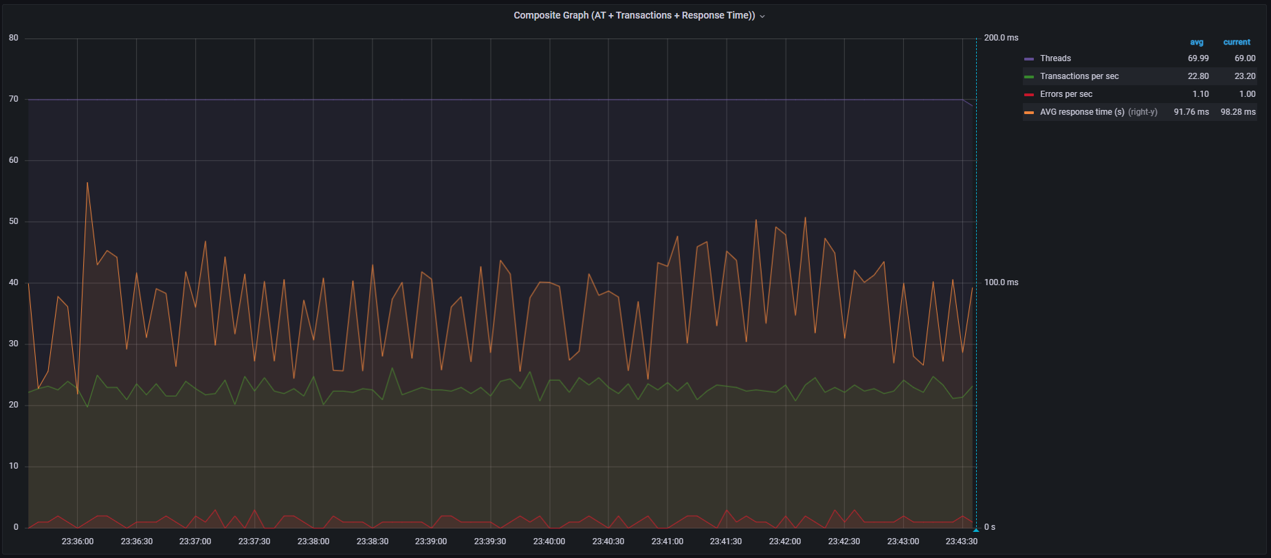

**Aggregate Report**

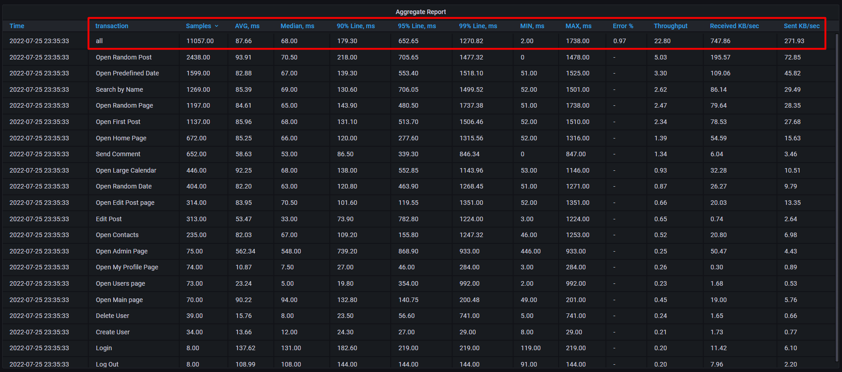

**All transaction response times**

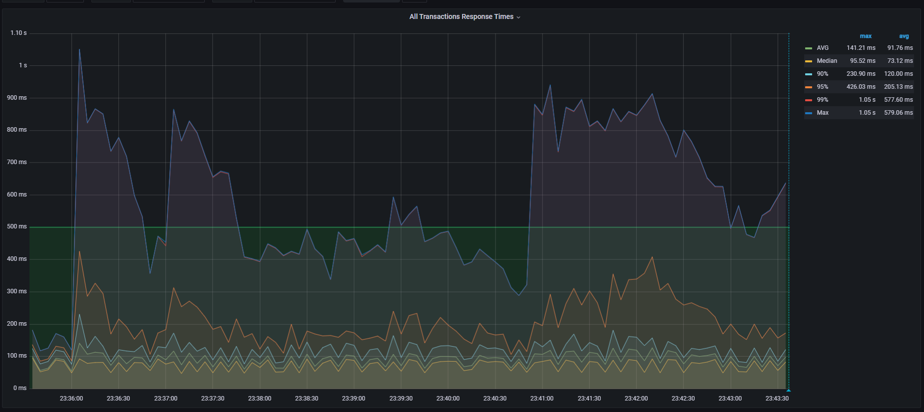

**CPU load**

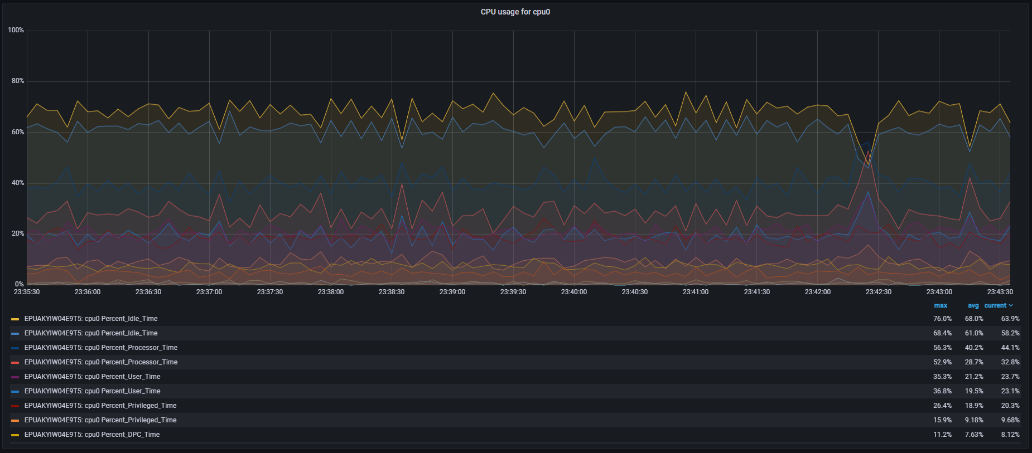

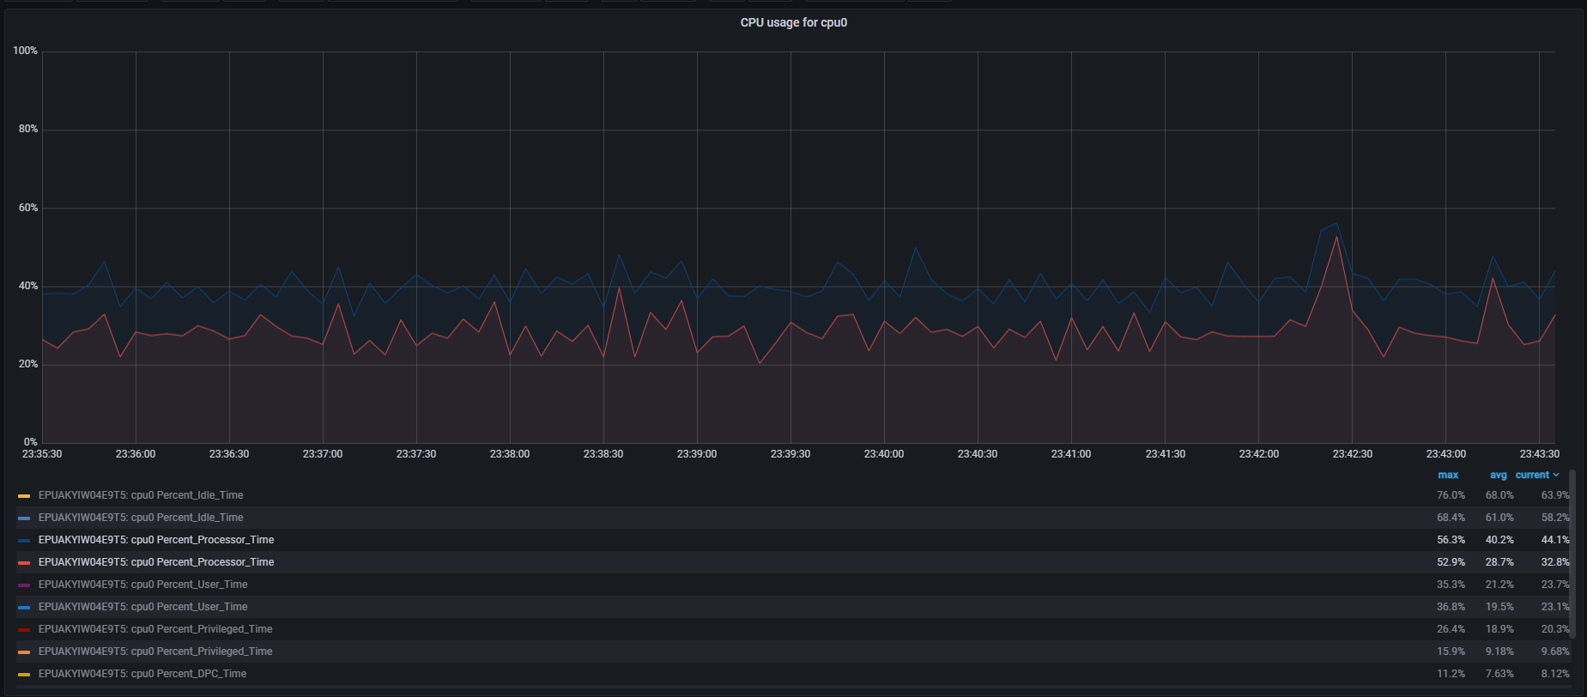

**Memory usage**

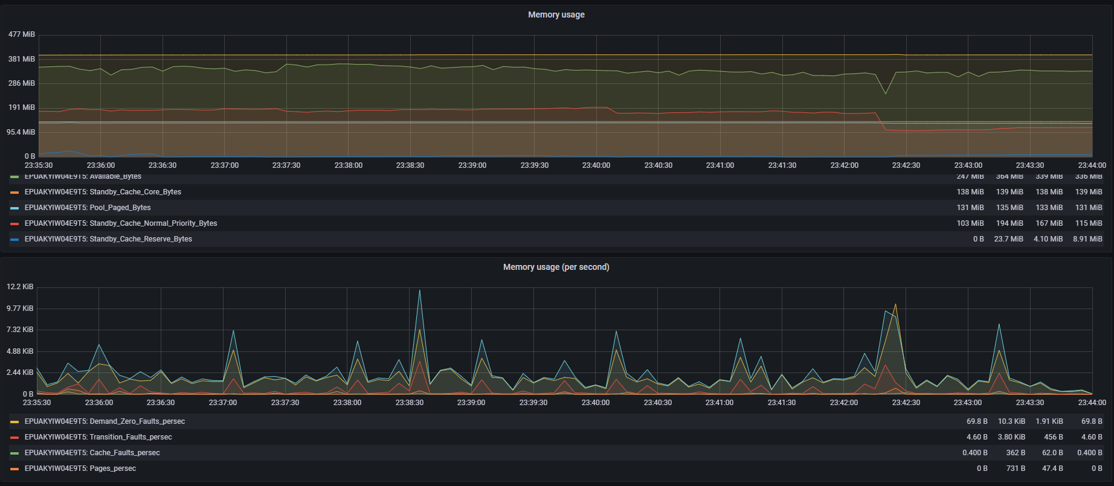

**Garbage Collector**

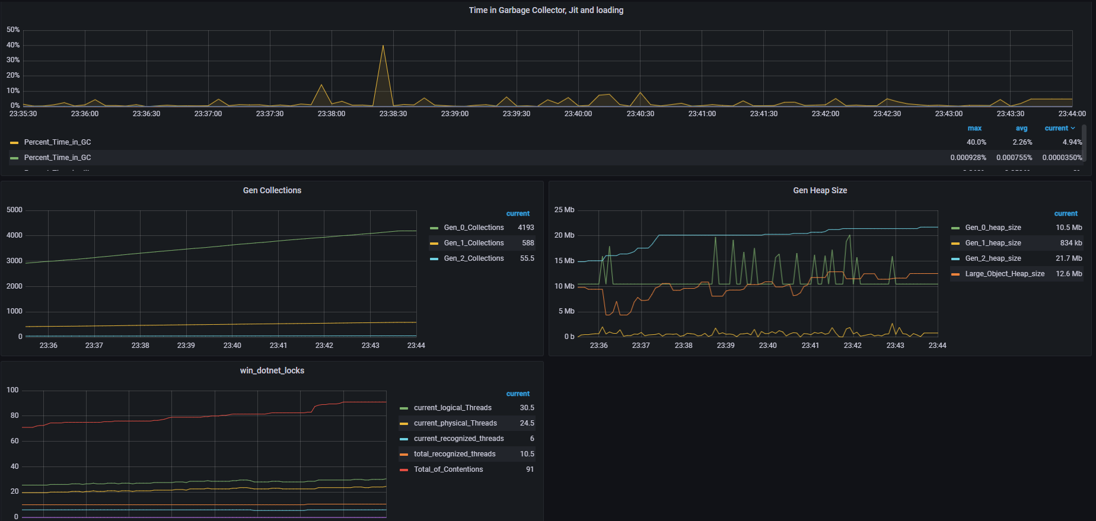

**Cache**

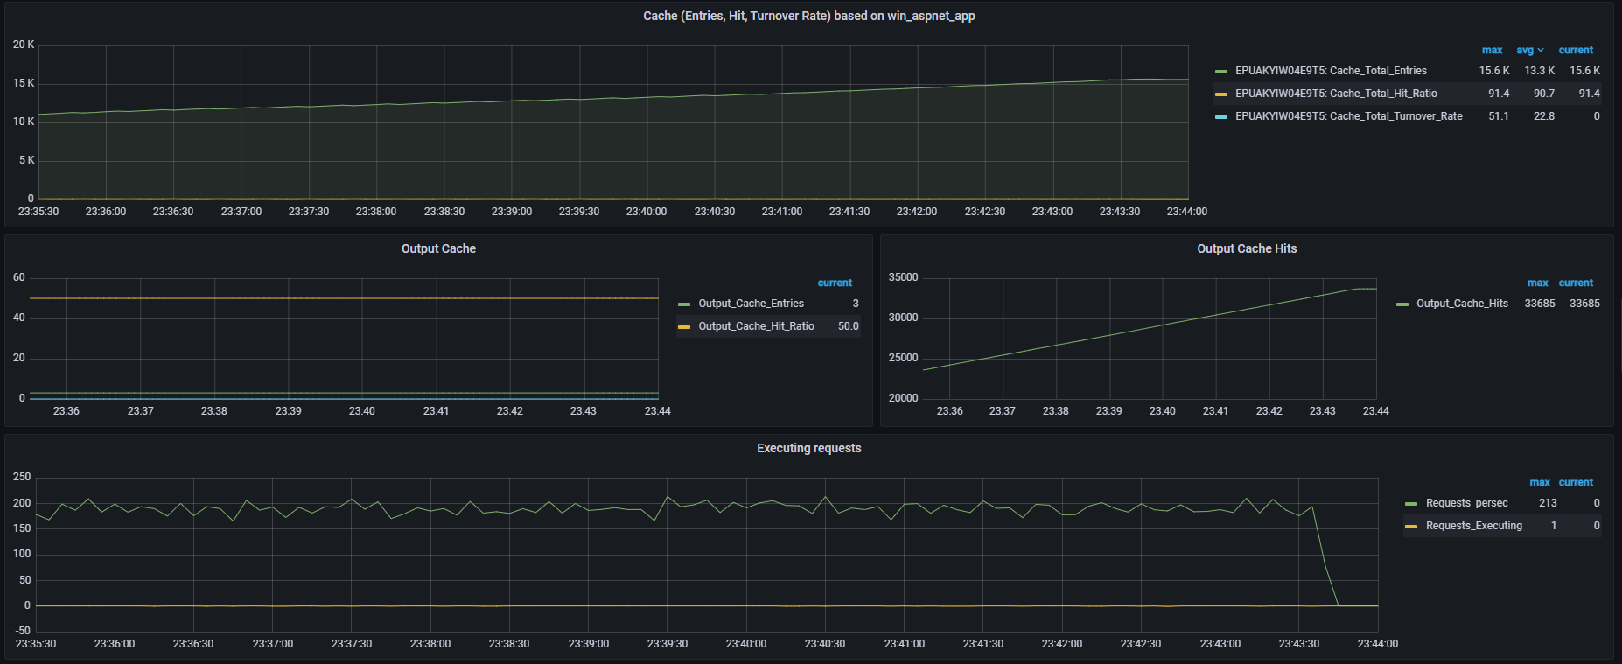

### 4096 MB RAM

**Composite Graph (Active Threads, Throughput, Average Response Time, Errors per sec)**

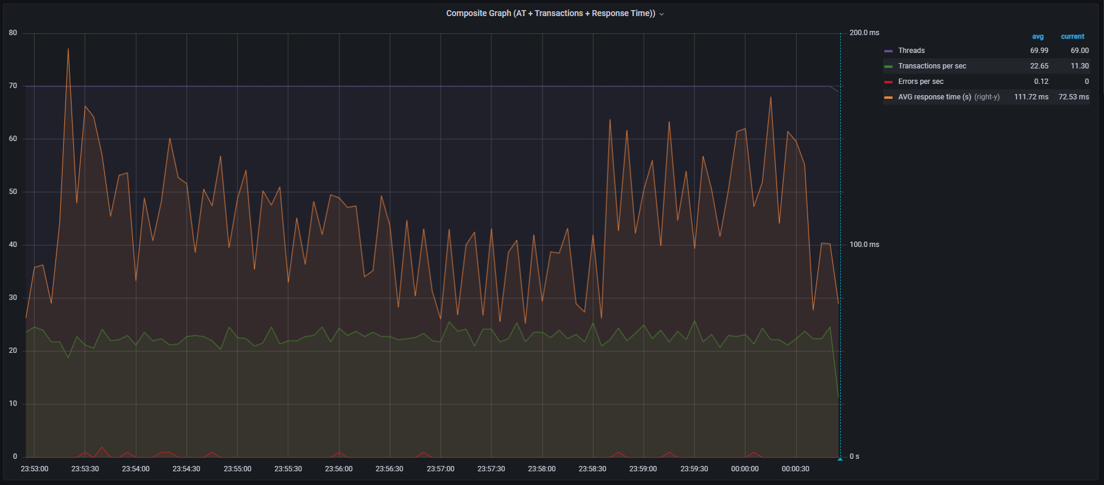

**Aggregate Report**

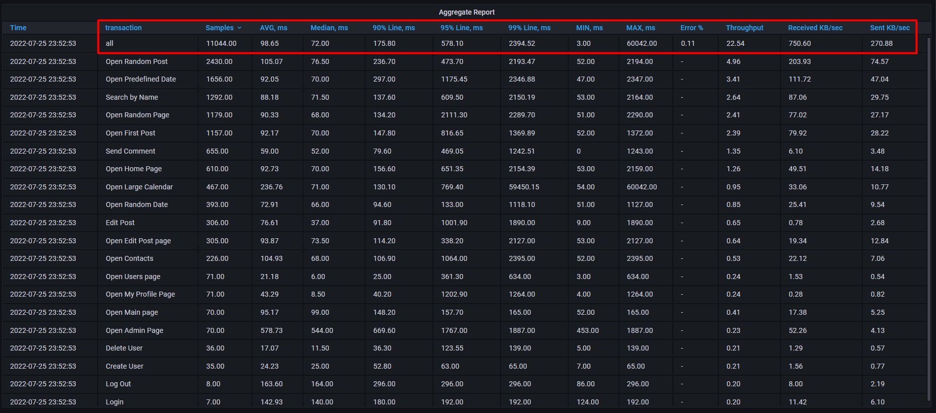

**All transaction response times**

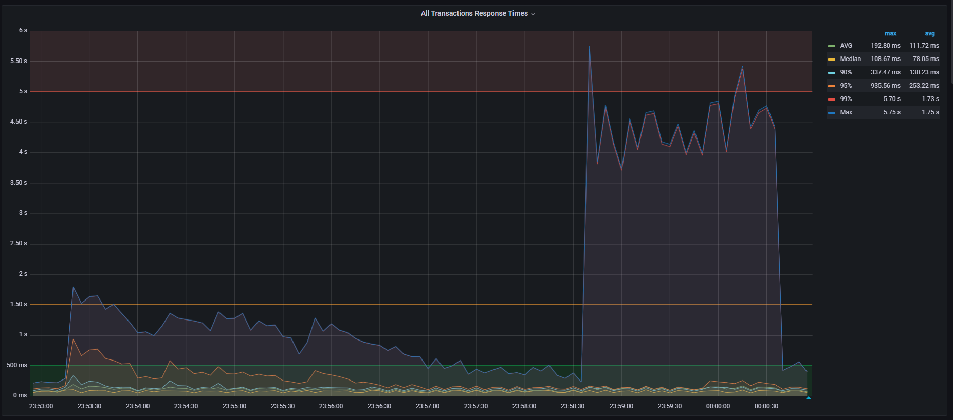

**CPU load**

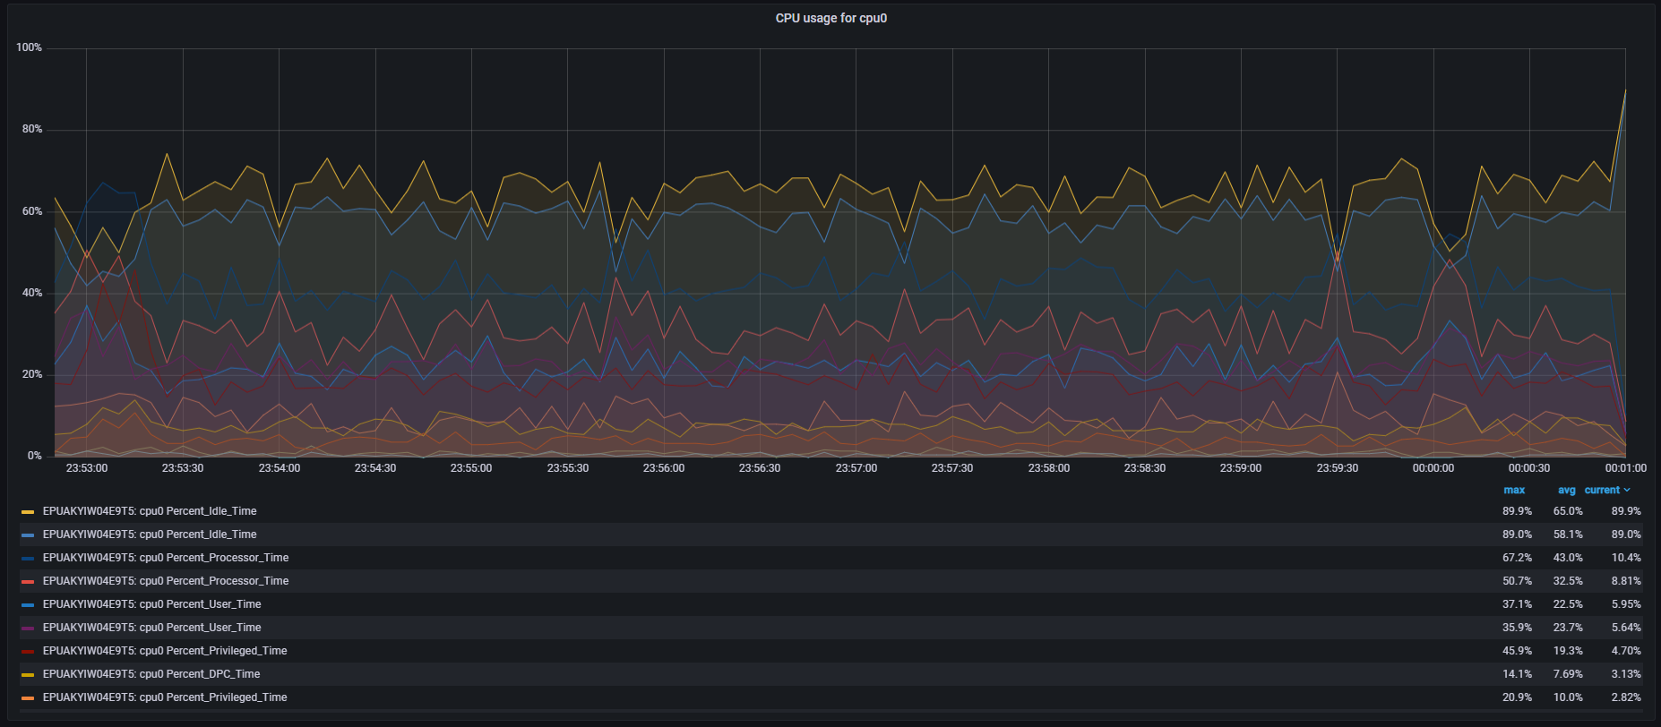

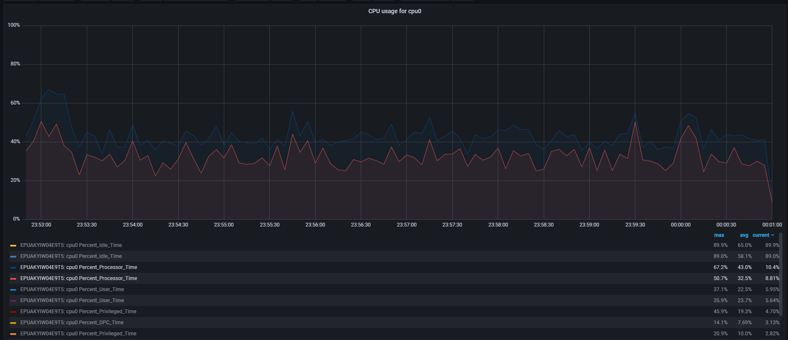

**Memory usage**

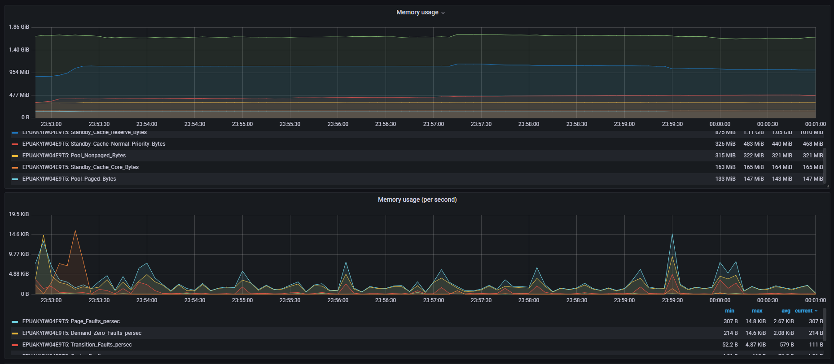

**Garbage Collector**

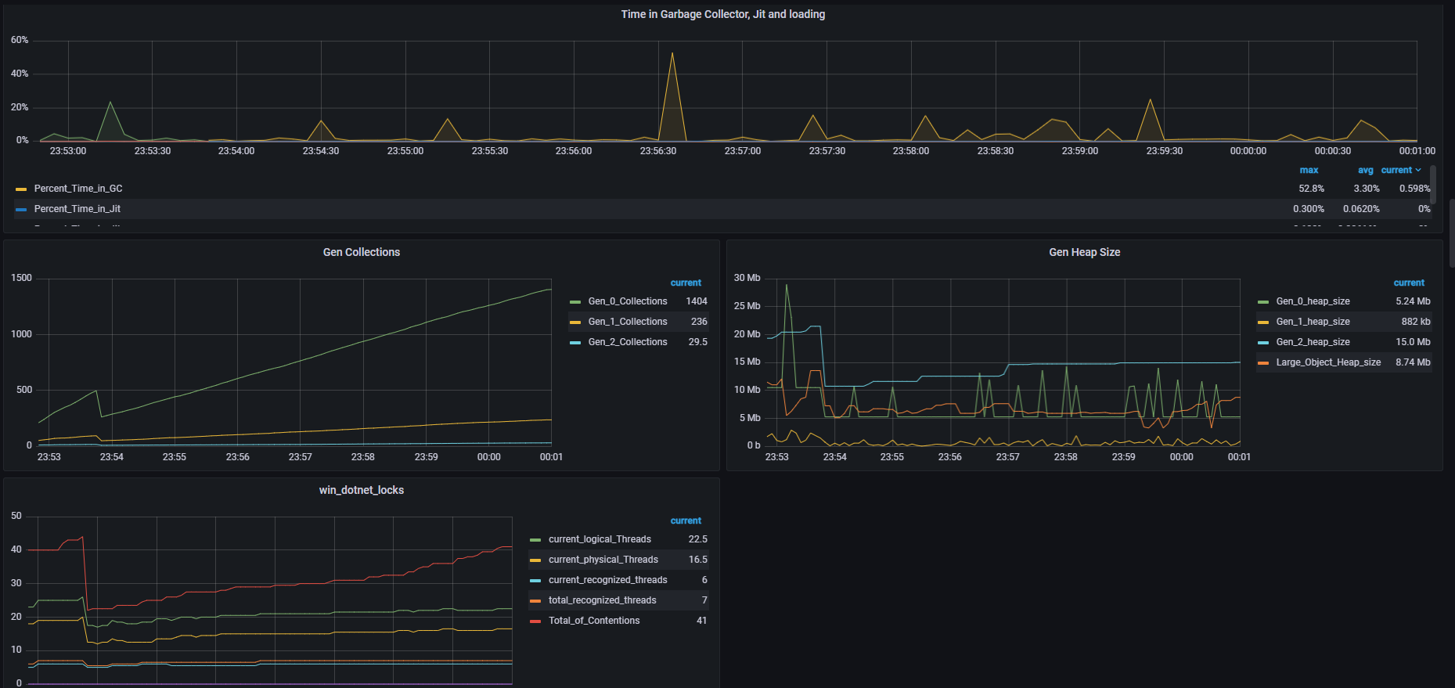

**Cache**

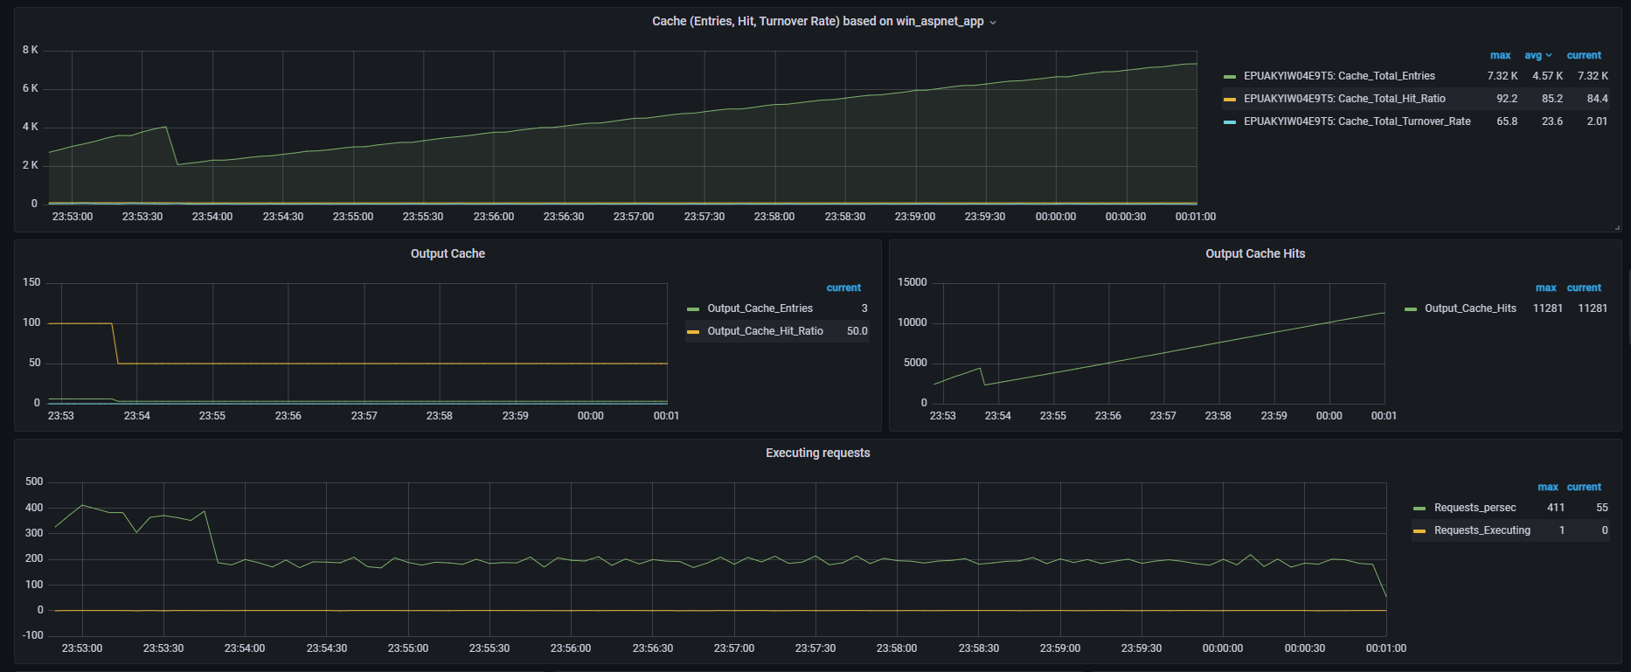

### 6144 MB RAM

**Composite Graph (Active Threads, Throughput, Average Response Time, Errors per sec)**

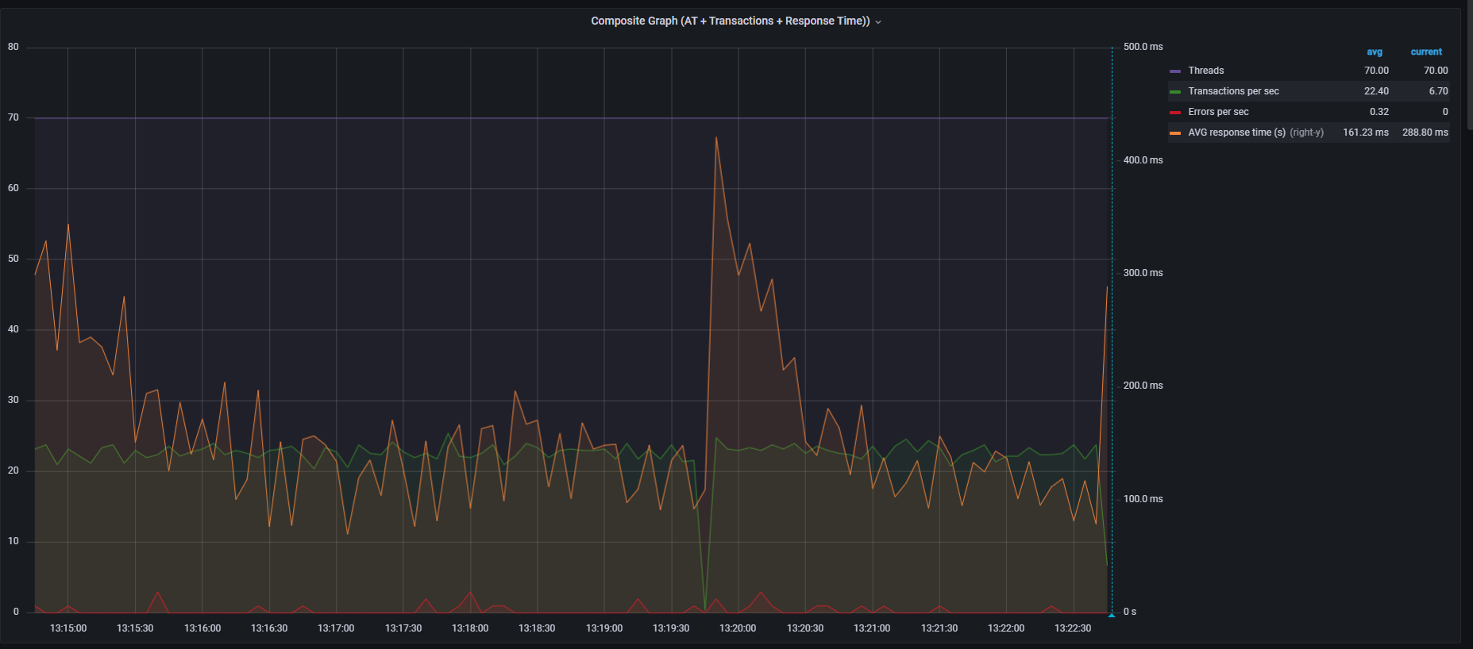

**Aggregate Report**

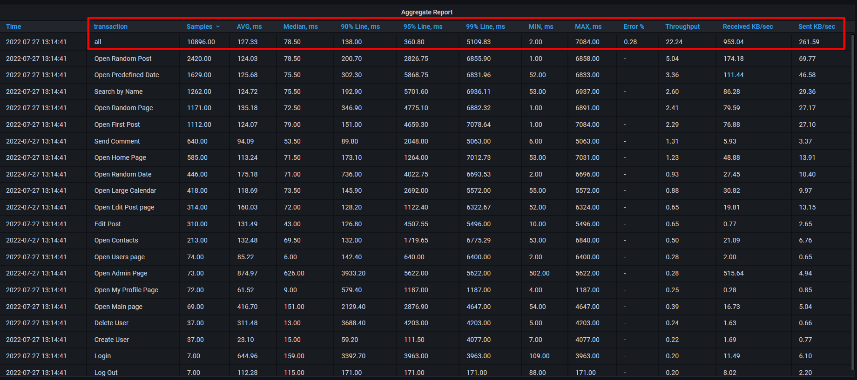

**All transaction response times**

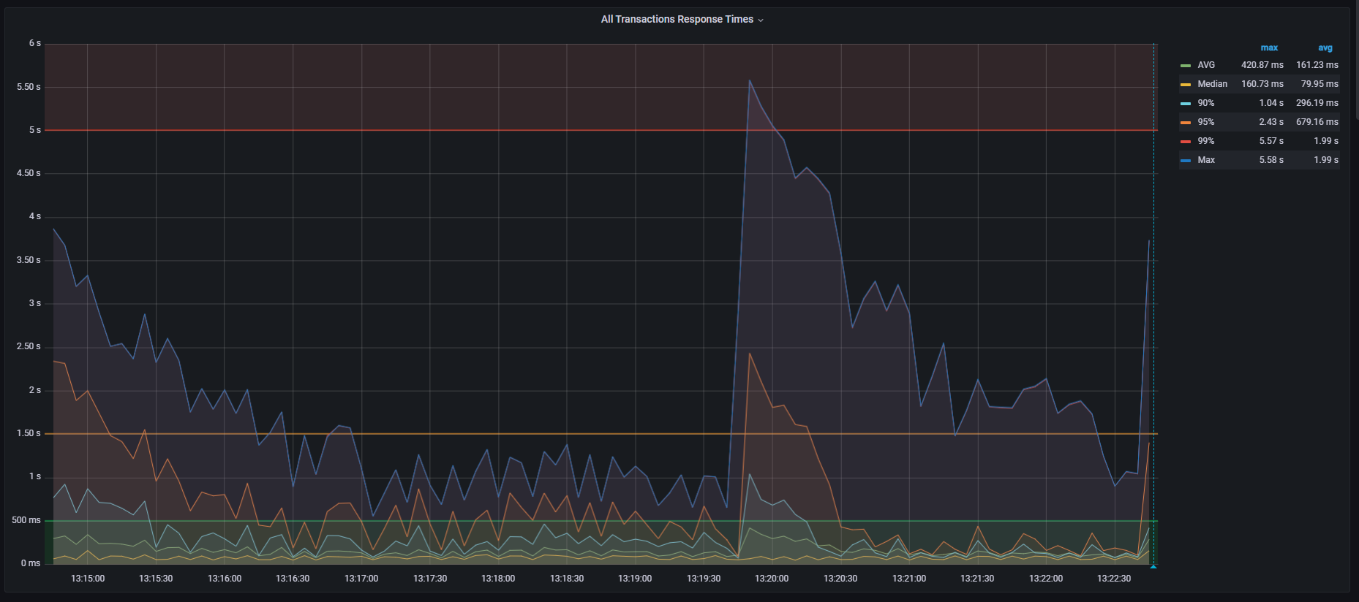

**CPU load**

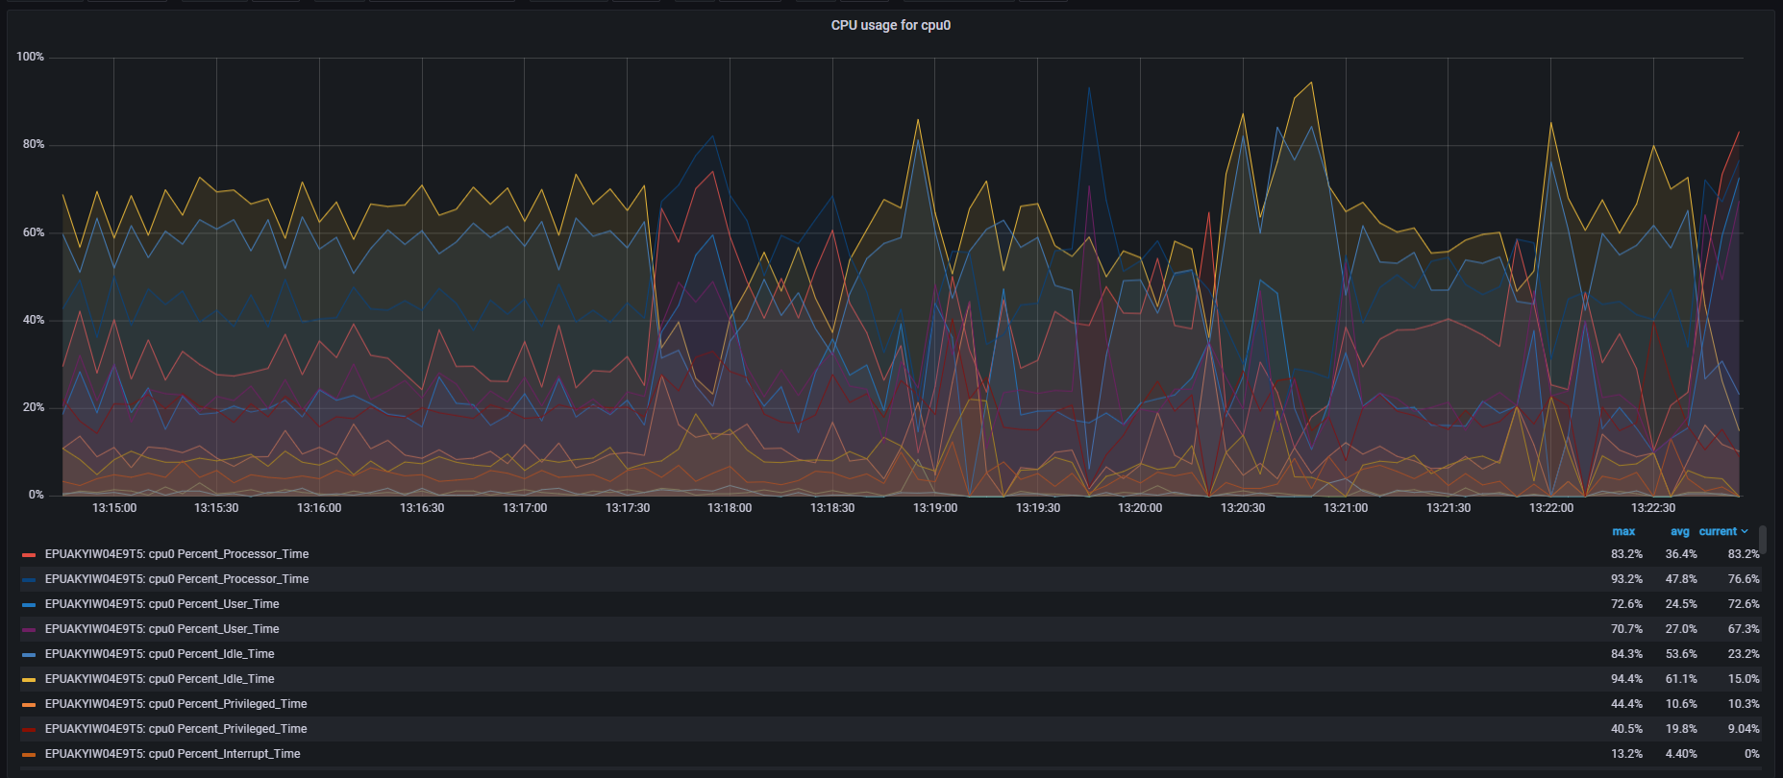

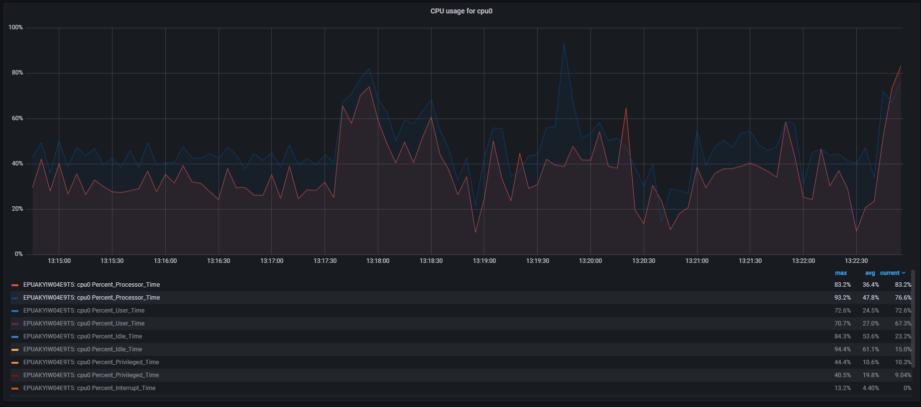

**Memory usage**

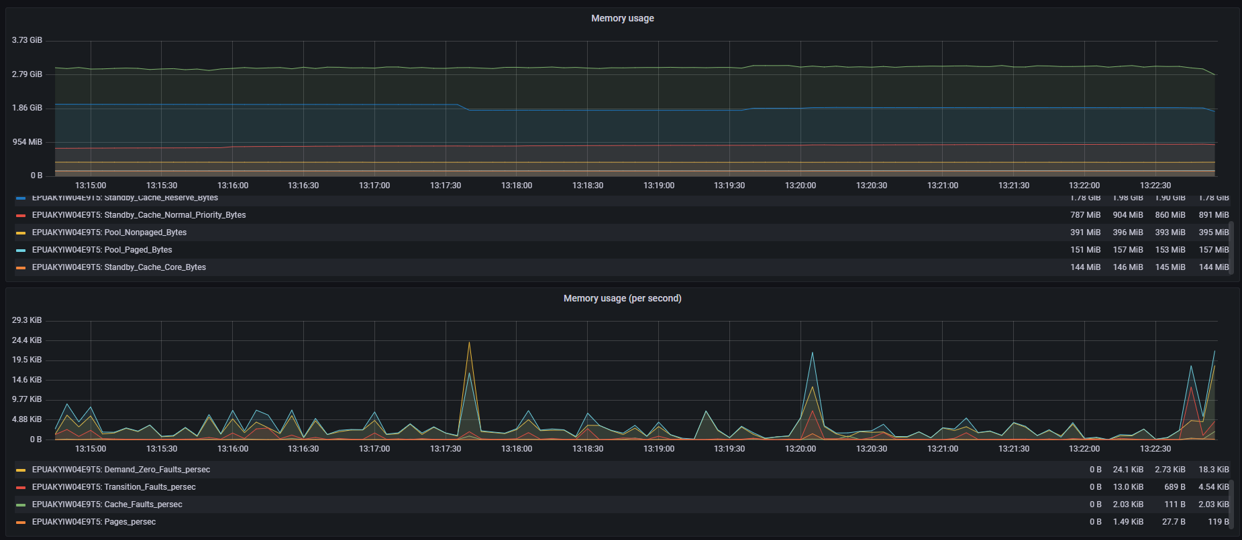

**Garbage Collector**

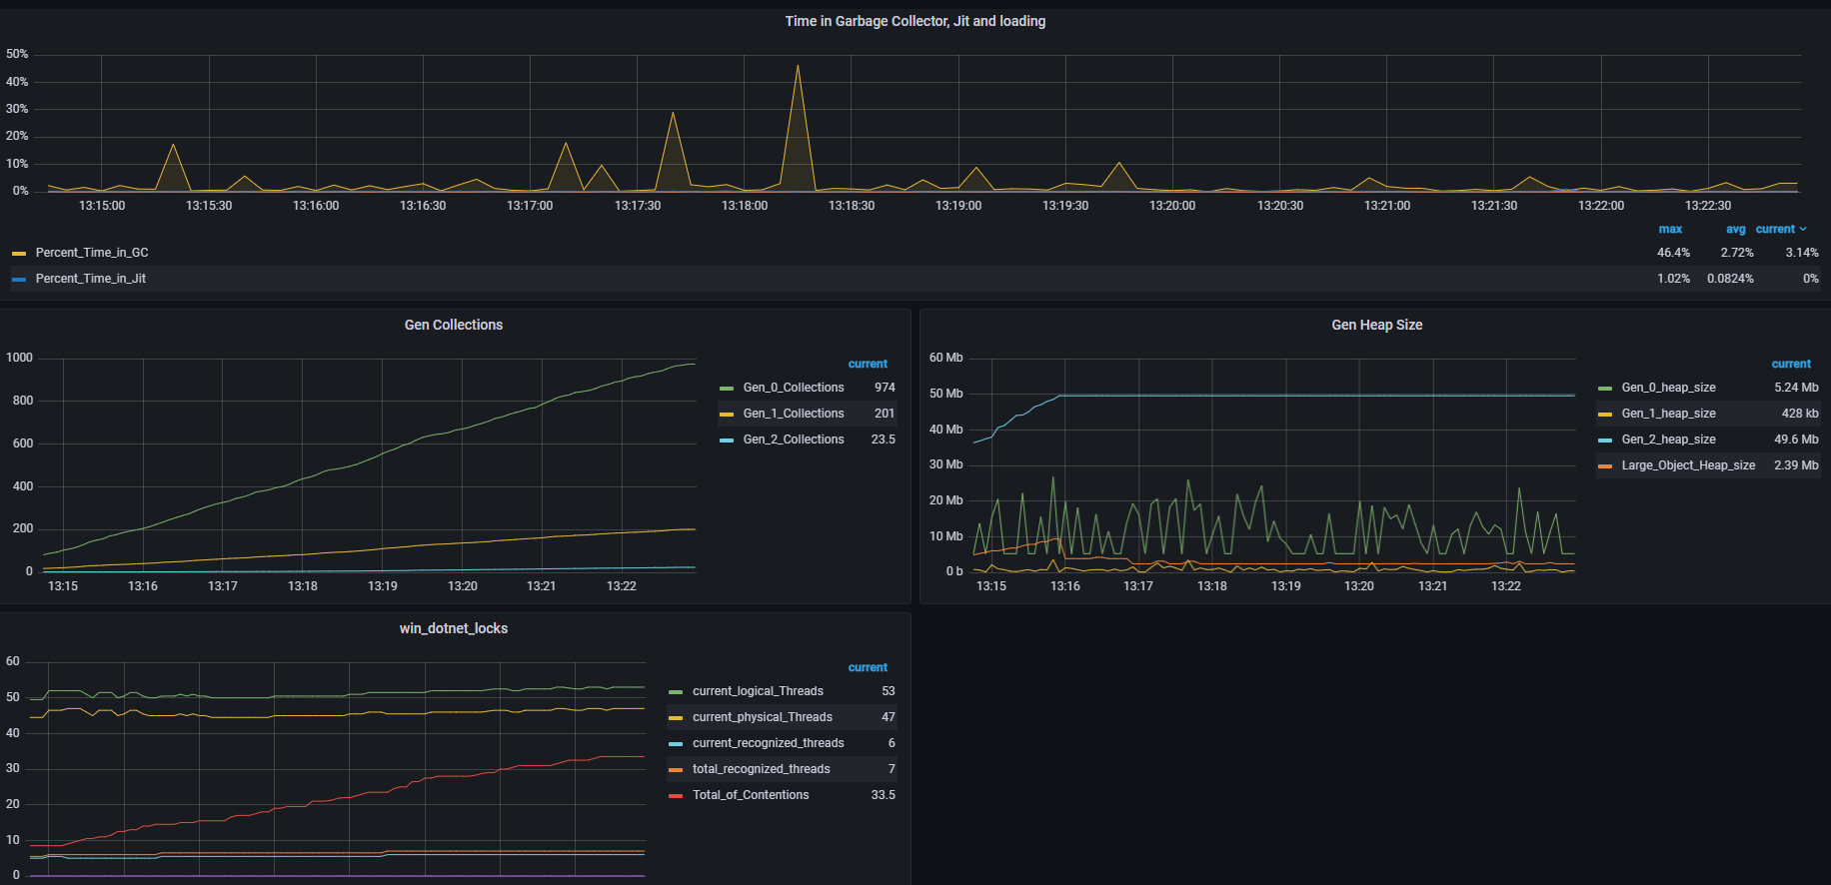

**Cache**

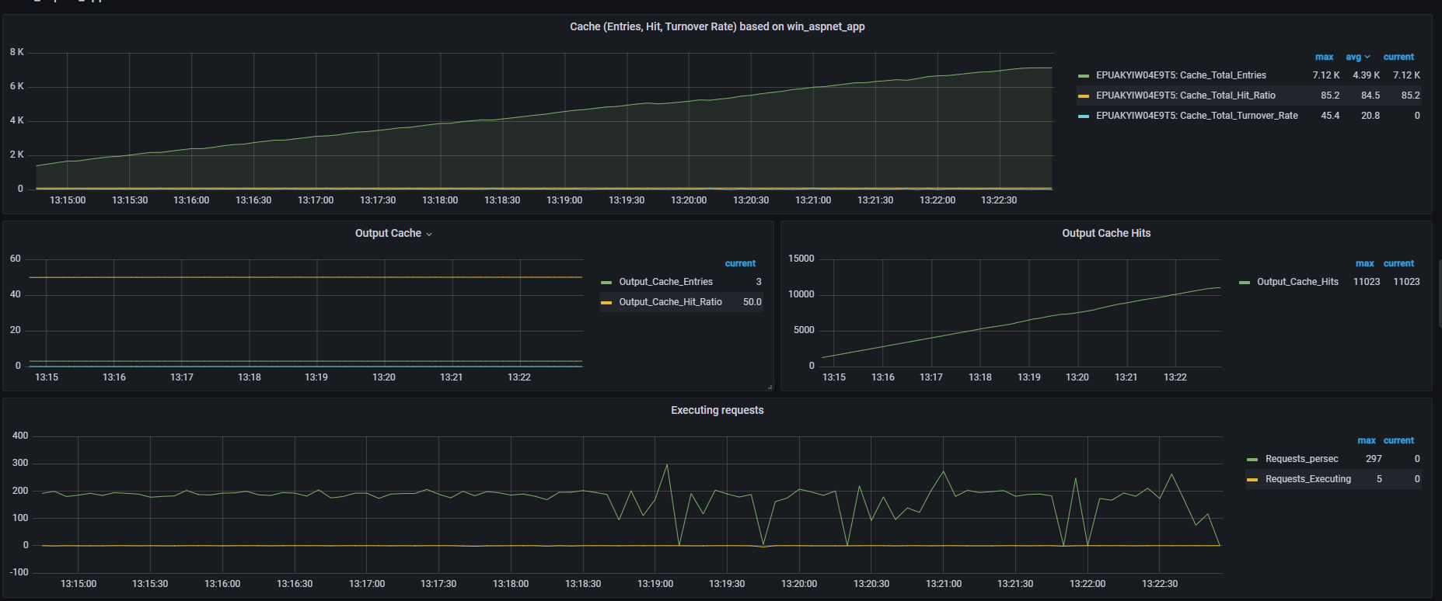

# Conclusion:

* We executed test for 8 different configuration which are listed in “Tests preconditions and configurations” section.
* First 4 runs were executed for case with fixed RAM 8 GB and scalable CPU: they showed most optimal CPU case is 2 Cores, because of lowest error rate and all response time metrics. Important to note that 3 Cores CPU also showed good results which were close to 2 Core case, but still they were bit worse than 2 Core. If we include here cost of purchase and maintain – 2 Core CPU is most optimal to run BlogEngine application.
* Next 3 runs were executed for fixed CPU 2 Cores and scalable RAM: they showed some unstable results for 2 GB and 6 GB cases, while 4 GB case showed better results in response time comparing to 8 GB which we executed in previous part.
* Comparing of Default config (1 Core CPU + 4 GB RAM) and the most optimal after scaling of RAM and CPU (2 Core CPU + 4 GB RAM):

|  |  |  |
| --- | --- | --- |
| **CPU** | 1 Core | 2 Core |
| **RAM** | 4 GB | 4 GB |
| **Throughput (transactions per sec)** | 21.44 | **22.54** |
| **Error rate, %** | **0.03** | 0.11 |
| **Average response time, ms** | 255.62 | **98.65** |
| **Median response time, ms** | 205.5 | **72** |
| **90%, ms** | 1191.2 | **175.8** |
| **95%, ms** | 2235.8 | **578.1** |

* + Looking into comparing of these two cases we can **conclude** that additional 0.08% error rate and slight increase of costs between 1 Core CPU and 2 Core CPU can be acceptable to have **65% lower median** response time, **85% lower 90 percentile** response time and **74% lower 95** **percentile** response time. So we choose **2 Core CPU and 4 GB RAM** as most optimal configuration to run BlogEngine application.